Household Inventory Management System

Isaac Tucker

CST-452 Capstone Project Development Status Report

Grand Canyon University

Instructor: Michael Landreth

Date: 05/15/2022

|  |  |  |
| --- | --- | --- |
|  | **[Household Inventory Management System]** | **CST-452 Weekly Capstone Project Status Report** |

|  |  |
| --- | --- |
| **Project Phase:** | *Sprint Planning / Sprint 4.0* |
| **Date:** | *05/15/2022* |
| **Team:** | 1. *Isaac Tucker* |
| **Status:** | |  |  |  |  | | --- | --- | --- | --- | | **Task** | **Team**  **Member** | **Hours**  **Worked** | **Hours Remaining** | | *Added ability to share household access* | *Isaac Tucker* | *4* | *0* | | *Added password encryption* | *Isaac Tucker* | *4* | *0* | | *Updated Authentication to check encryptions* | *Isaac Tucker* | *2* | *0* | | *Fixed bugs* | *Isaac Tucker* | *2* | *0* | |  |  |  |  | |  |  |  |  | |
| **Issues/Risks:** | |  |  |  |  | | --- | --- | --- | --- | | **Issue or Risk** | **Owner** | **Date**  **Reported** | **Date Resolved** | | *Unsure of how to secure password artifacts in git repo.* | *Isaac Tucker* |  |  | |  |  |  |  | |  |  |  |  | |  |  |  |  | |

|  |
| --- |
| **Overall Instructor Feedback/Comments** |

**I have Integrated Instructor Feedback into Project My Documentation.**

Yes  No

**I met with my Mentor this week.**

Yes  No

Front-End: <https://hhim.herokuapp.com/> Back-End: <https://hhim-rest.herokuapp.com/>

Table of Contents

Implementation Plan 4

Epics: 4

Database: 6

Back-End NodeJS/ExpressJS Rest Service 7

ReactJS Front-End 9

Mapping of Functional Requirements 11

Functional Requirements 11

Mapping 13

Source Code Listing 14

Back-end ExpressJS Rest Service: 14

Front-end ReactJS: 15

Test Plan and Test Cases 18

REST Service Tests: 18

User: 18

Household Users: 32

Households: 42

Items: 53

Reports: 65

Front-End Tests: 66

1 Register 66

2 Login 67

3 Add Household 68

4 Delete Household 69

5 Update Household 70

6 View Household 71

7 View Items 72

8 Add Item 73

9 Update Item 74

10 Delete Item 75

11 Flag Item for Donation 76

12 Invite Collaborators 77

Application Demonstration 78

# Implementation Plan

## Epics:

The main components of the application architecture is broken into a series of epics.

Current Statuses:

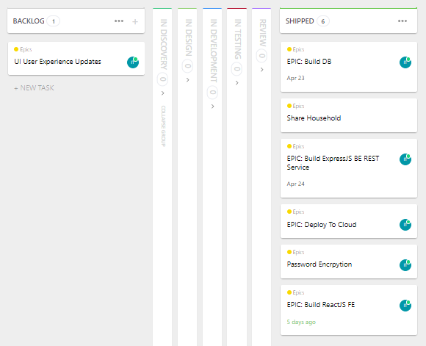

The architecture expectation is as follows:

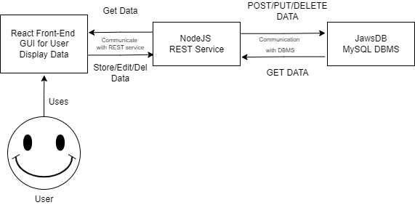

Gantt Chart:

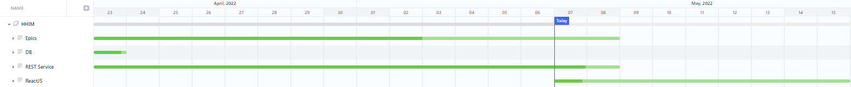

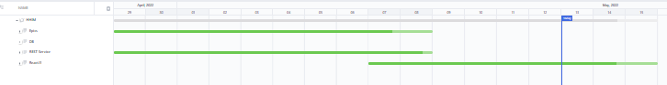

Note: I may need to revaluate the ‘deadlines’ indicated for certain items.

## Database:

The database epic consists of the following tasks. All of these tasks are currently shipped and there is nothing in the database backlog. So, for now, I am showing a list of the completed work items instead of the progress board.

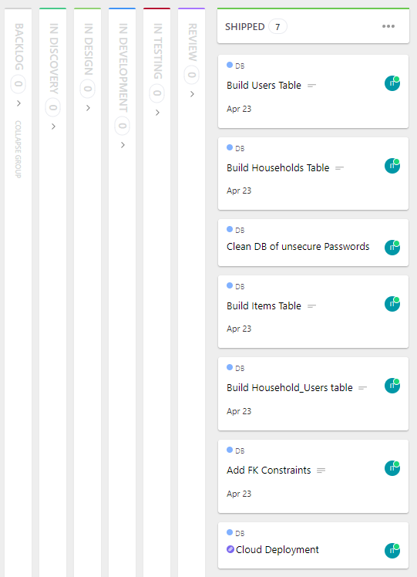

## Back-End NodeJS/ExpressJS Rest Service

The back-end NodeJS/ExpressJS Rest Service Epic consists of the following items.

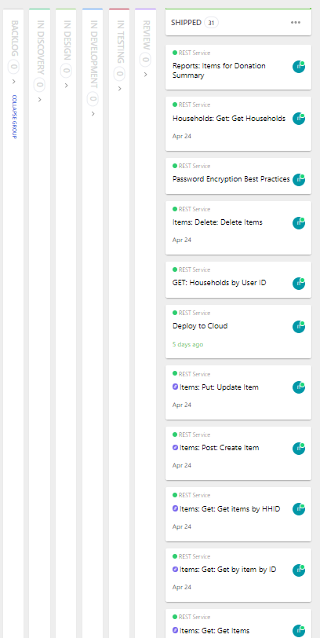

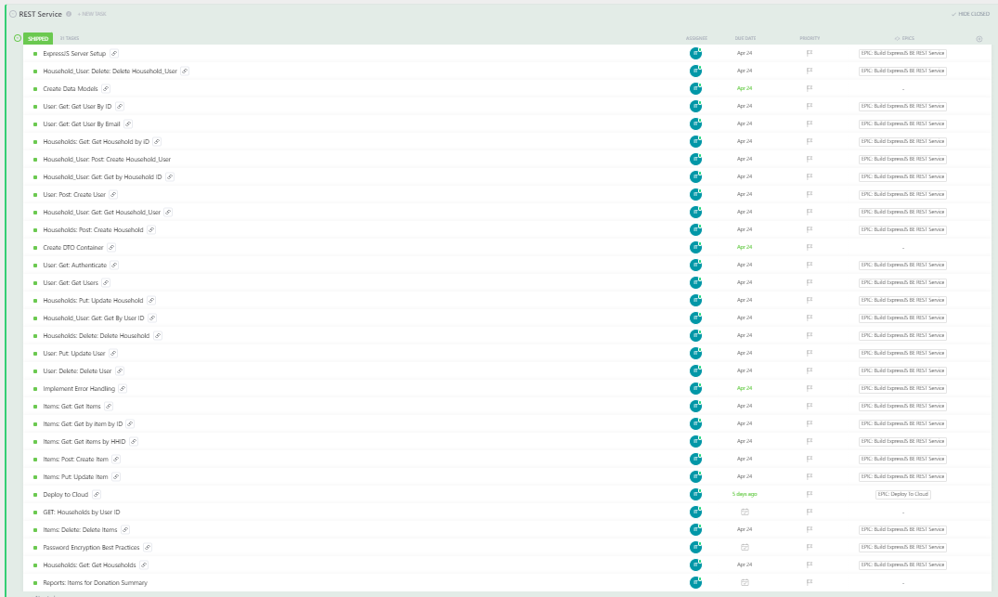

The back-end REST service has many parts. The above is the list of work items are the board cannot all be captured in one easy image.

## ReactJS Front-End

The ReactJS Front End has not been started yet so all items are in the backlog.

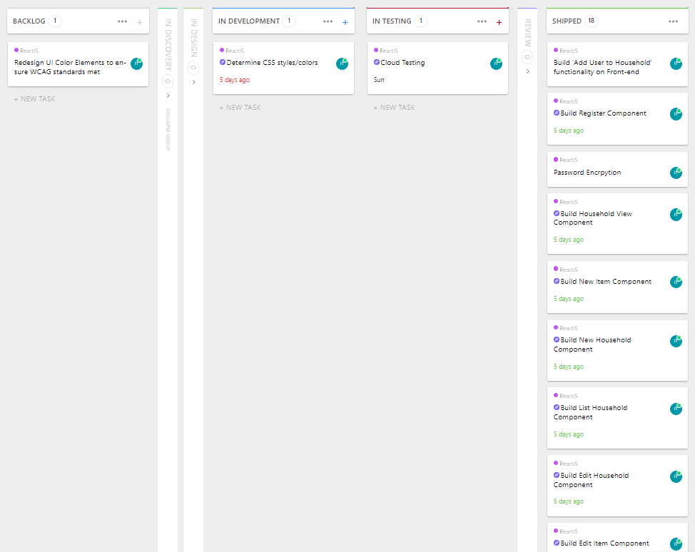

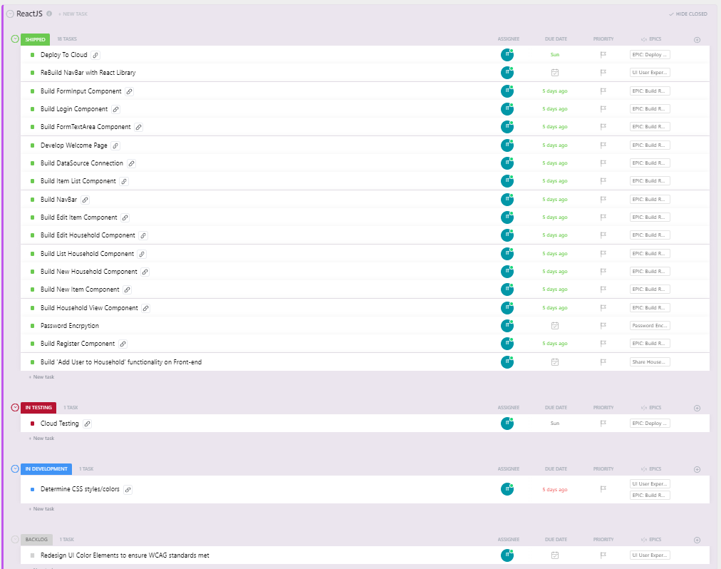

# Mapping of Functional Requirements

## Functional Requirements

Epic:

As a user I want a system where I can track my various items that I have within my household(s).

User Stories:

* **Register**: As a user I want to be able to register with the application so I can use the application and have a unique account to associate my household entries with.
  + Store user information in a relational database to be used for authentication purposes and to associate affiliated household instances.
* **Login**: As a user I want to be able to log into my account to access my households.
  + Authenticate provided user credentials against those stored within the relational database to allow access to application features and associated household instances.
* **Add household**: As a user I want to be able to make different household listings so I can separate items based off different locations.
  + Store household instance data in a relational database along with associated user id for future reference.
* **Delete household**: As a user I want to be able to delete households in case I no longer need the inventory list.
  + Delete household instance data from relational database if associated with active user.
* **Update household inventory**: As a user I want to be able to update my household information in case I made a mistake or details change.
  + Update household instance data within relational database if associated with active user.
* **View households owned/managed by user**: As a user I want to be able to view the households that I am managing.
  + Retrieve all household instance data for any given user id associated with active user and display those households within the application UI.
* **View household items for households owned/managed by user**: As a user I want to be able to view the inventory items that are currently in a select household.
  + Retrieve all items associated with a given household id associated with a given active user and display those items within the application UI.
* **Add Items to household**: As a user I want to be able to add items to a household listing.
  + Store provided item instance data in the relational database and associate new data with the selected household id for the associated active user.
* **Delete Items from household**: As a user I want to be able to delete items from a household listing.
  + Delete selected item instance data from the relational database for the selected household associated with the active user.
* **Update Items in household**: As a user I want to be able to update item information within a household.
  + Update provided item instance data for a given item id in the relational database for the associated active user.
* **Flag for donation**: As a user I want to be able to flag items for donation.
  + Set the donation flag to true for the given item id in the relational database. This will then be indicated on the application UI.
* **Invite Collaborators**: As a user I want to be able to invite other users to also add to my households.
  + Provide a text field to add contributors to a selected household instance associated with a given active user. If the intended contributor is a user within the system then associate that selected household id with the intended contributor account. The contributor will now have that household displayed within their application UI for CRUD privileges.

## Mapping

|  |  |  |  |  |  |
| --- | --- | --- | --- | --- | --- |
| **REQUIREMENTS TRACEABILITY MATRIX** | | | |  |  |
| Project Name: |  | Household Inventory Management System |  |  |  |
| Project Description: | | A place to store a list of items within one's household. | |  |  |
| ***ID*** | ***Assoc ID*** | ***Functional Requirement / Use Case*** | ***Architectural/Design Document*** | ***Software Module(s)*** | **Test Case Number** |
| 001 | 1.0.1 | Register | Final Plan Document | FE - Register Component.  BE - UserDAO | *Test001* |
| 002 | 1.0.2 | Login | Final Plan Document | FE - Login Component.  BE - UserDAO | *Test002* |
| 003 | 2.0.1 | Add Household | Final Plan Document | FE - New Household Component  BE - HouseholdDAO | *Test003* |
| 004 | 2.0.2 | Delete Household | Final Plan Document | FE - View Household Component  BE - HouseholdDAO | *Test004* |
| 005 | 2.0.3 | Update Household | Final Plan Document | FE - Edit Household Component.  BE - HouseholdDAO | *Test005* |
| 006 | 2.0.4 | View Household | Final Plan Document | FE - View Household Component  BE - HouseholdDAO | *Test006* |
| 007 | 3.0.5 | View Items | Final Plan Document | FE - View Item Component BE - ItemDAO | *Test007* |
| 008 | 3.0.1 | Add Item | Final Plan Document | FE - New Item Component BE - ItemDAO | *Test008* |
| 009 | 3.0.3 | Update Item | Final Plan Document | FE - Edit Item Component BE - ItemDAO | *Test009* |
| 010 | 3.0.2 | Delete Item | Final Plan Document | FE - View Item Component BE - ItemDAO | *Test010* |
| 011 | 3.0.4 | Flag Item for Donation | Final Plan Document | FE - View Item Component BE - ItemDAO | *Test011* |
| 012 | 4.0.1 | Invite Collaborators | Final Plan Document | FE - View Household Component  BE - HouseholdUsersDAO | *Test012* |

# Source Code Listing

## Back-end ExpressJS Rest Service:

GIT: <https://github.com/MrAizakku/HHIM_REST.git>

Link: <https://hhim-rest.herokuapp.com/>

Files:

Index.js

Single Page Application using ExpressJS. This file defines the server specifics, the COORS specification, the port being used, the various endpoints, and the error handling.

Models/Household.ts

The typescript object model for Household objects.

Models/HouseholdUser.ts

The typescript object model for HouseholdUser objects.

Models/Item.ts

The typescript object model for Item objects.

Models/User.ts

The typescript object model for User objects.

Models/Report.ts

The typescript object model for report objects.

Database/DTO.ts

The typescript object model for the data transfer object. This object is to encapsulate the data being transferred to and from the database.

Database/HouseholdDAO.ts

This typescript object defines the database interaction behaviors for the household object and households table.

Database/HouseholdUserDAO.ts

This typescript object defines the database interaction behaviors for the household object and householduser table.

Database/ItemDAO.ts

This typescript object defines the database interaction behaviors for the household object and items table.

Database/UserDAO.ts

This typescript object defines the database interaction behaviors for the household object and users table.

Database/ReportDAO.ts

This typescript object defines the database interaction behaviors for the report object and report oriented queries to the DB.

## Front-end ReactJS:

GIT: https://github.com/MrAizakku/HHIM.git

Link: https://hhim.herokuapp.com/

Files:

Forms

FormInput.js

A component for the easy implementation of form related input textbox fields

FormTextArea.js

A component for the easy implementation of form related input text area fields

Household

EditHousehold.js

Component for editing household objects. Loads household data into text fields and PUTs to REST to persist changes.

ListHouseholds.js

Component to load households for given user id and list said households in table view for selection purposes.

NewHousehold.js

Component for creation of new household objects. Contains necessary input fields for household object and POSTs to the REST service to persist household creation.

OneHousehold.js

Component for viewing one household and that household’s item array. Provides links to edit, and delete household. Also provides links to add items, edit items and delete items.

ShareHousehold.js

Component to add users to an existing household.

Item

EditItem.js

Component for editing item objects. Loads item data into text fields and PUTs to REST to persist changes.

ListItems.js

Component to load items for given household id and list said items in table view. Also provides links to edit and delete listed items.

NewItem.js

Component for creation of new item objects. Contains necessary input fields for item object and POSTs to the REST service to persist item creation for given household id.

Login

Login.js

Component for authentication and retrieval of existing user objects. Contains necessary input fields for user object authentication and POSTs to the REST service to check for authenticity. Once authenticated, GETs user info needed to load applicable household data.

Register

Register.js

Component for creation of new user objects. Contains necessary input fields for user object and POSTs to the REST service to persist user creation.

Report

Report.js

Component to load and render the display of items flagged for donation along with household State and user email.

App.js

Main app logic for route definition and main item loading from REST service.

dataSource.js

Defines the library to use for REST calls and the REST path itself.

index.js

Imports core ReactDOM and renders main App component at root.

NavBar.js

Component that defines top NavBar. Contains conditional logic to read local storage for login/logout navigation

Welcome.js

Component to contain application landing page. Also contains the report component to show visitors items for donation.

# Test Plan and Test Cases

## **REST Service Tests**:

### User:

POST: Create User

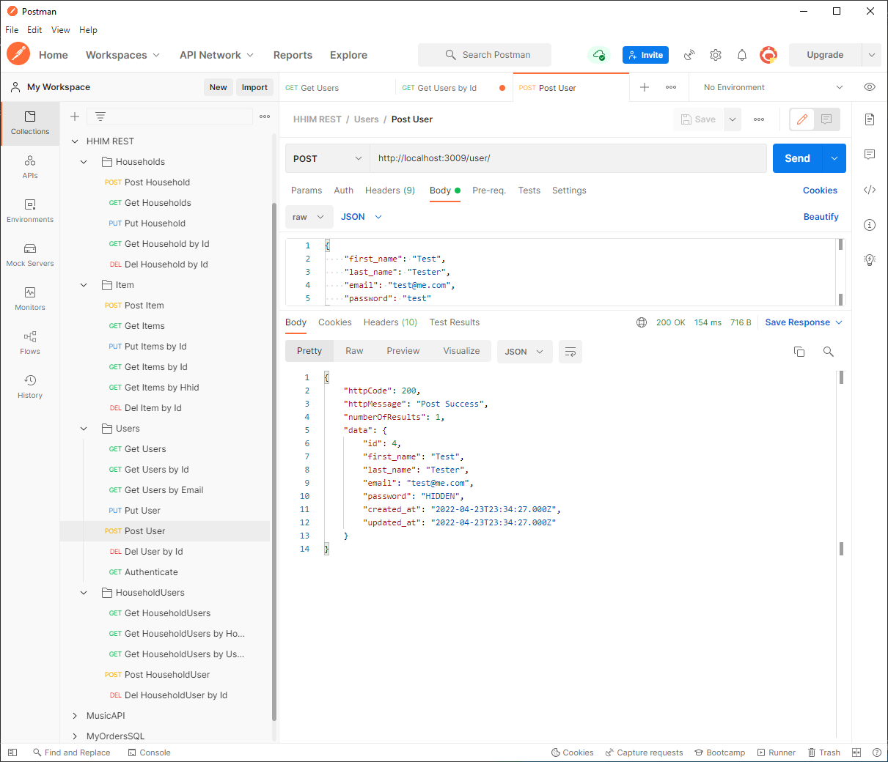

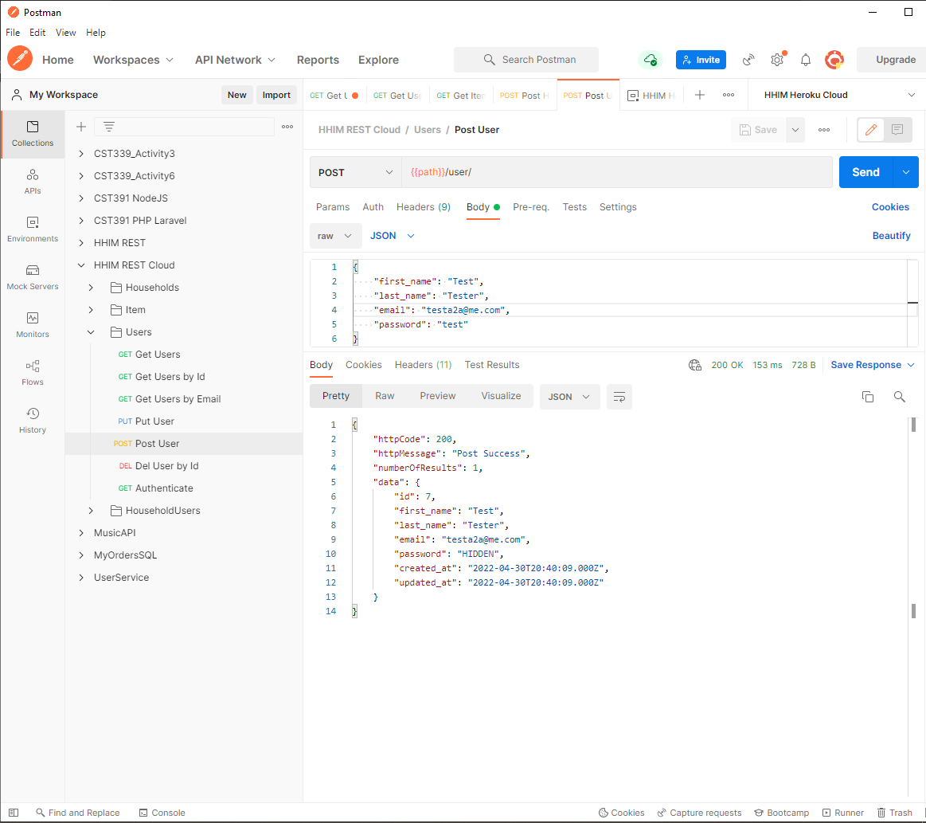

GET: Get User By ID

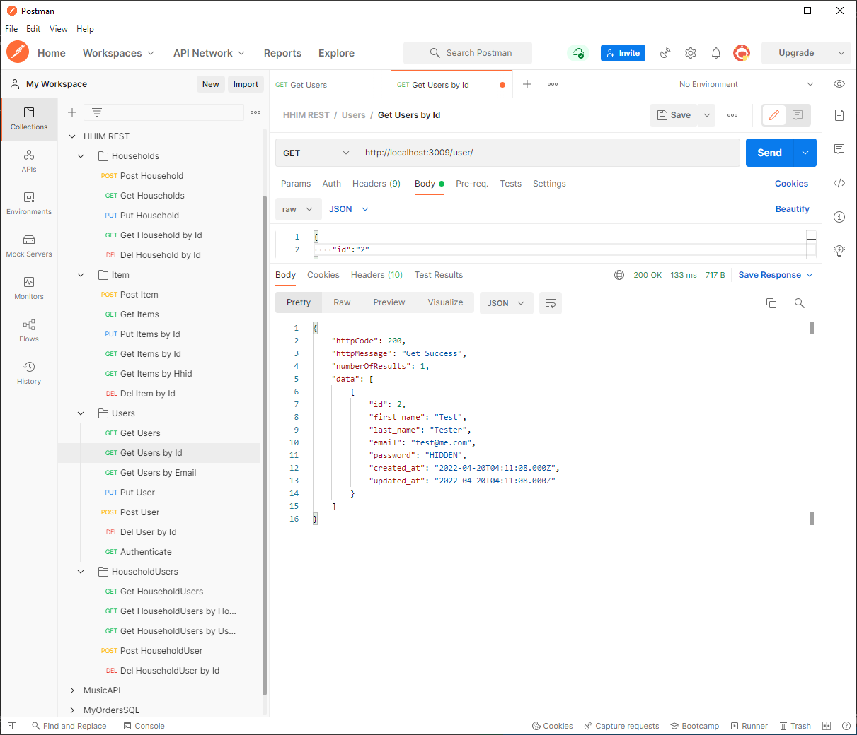

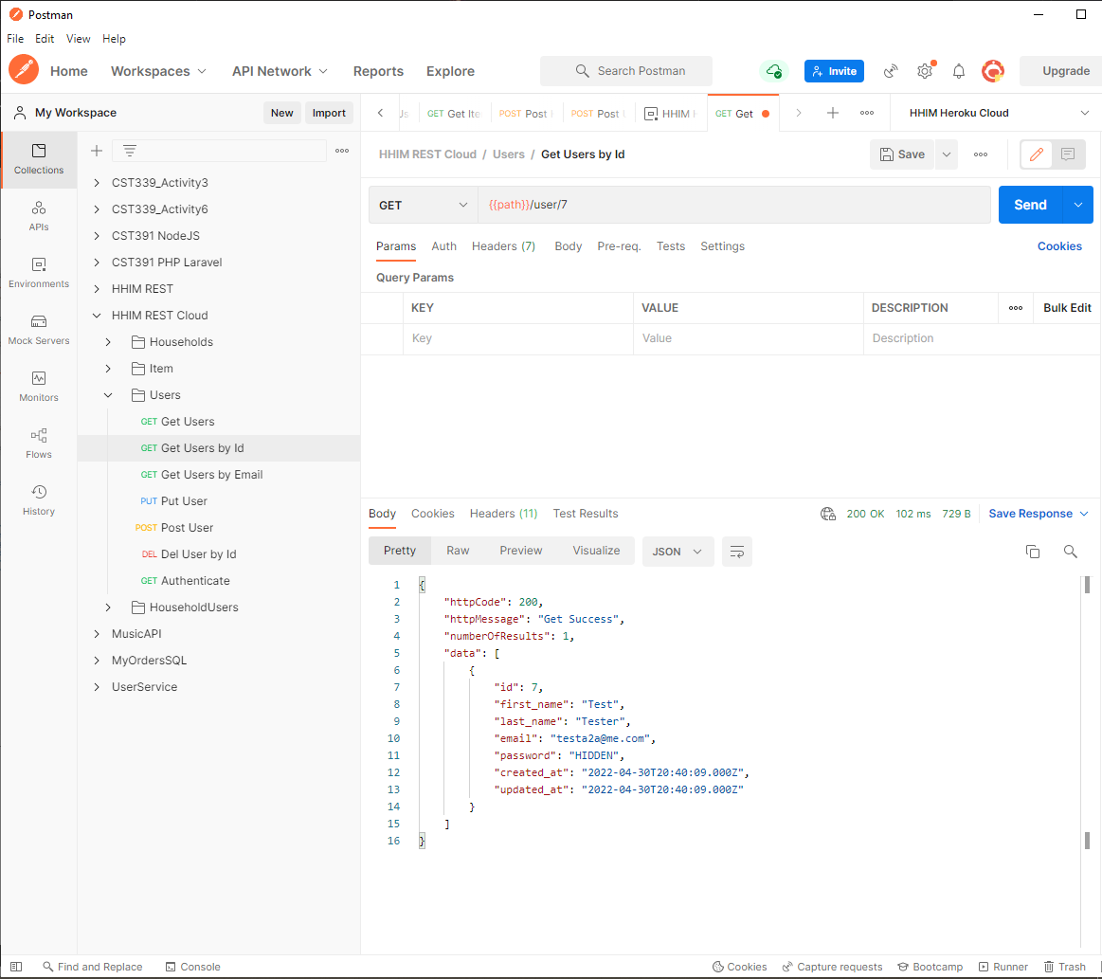

GET: Get Users

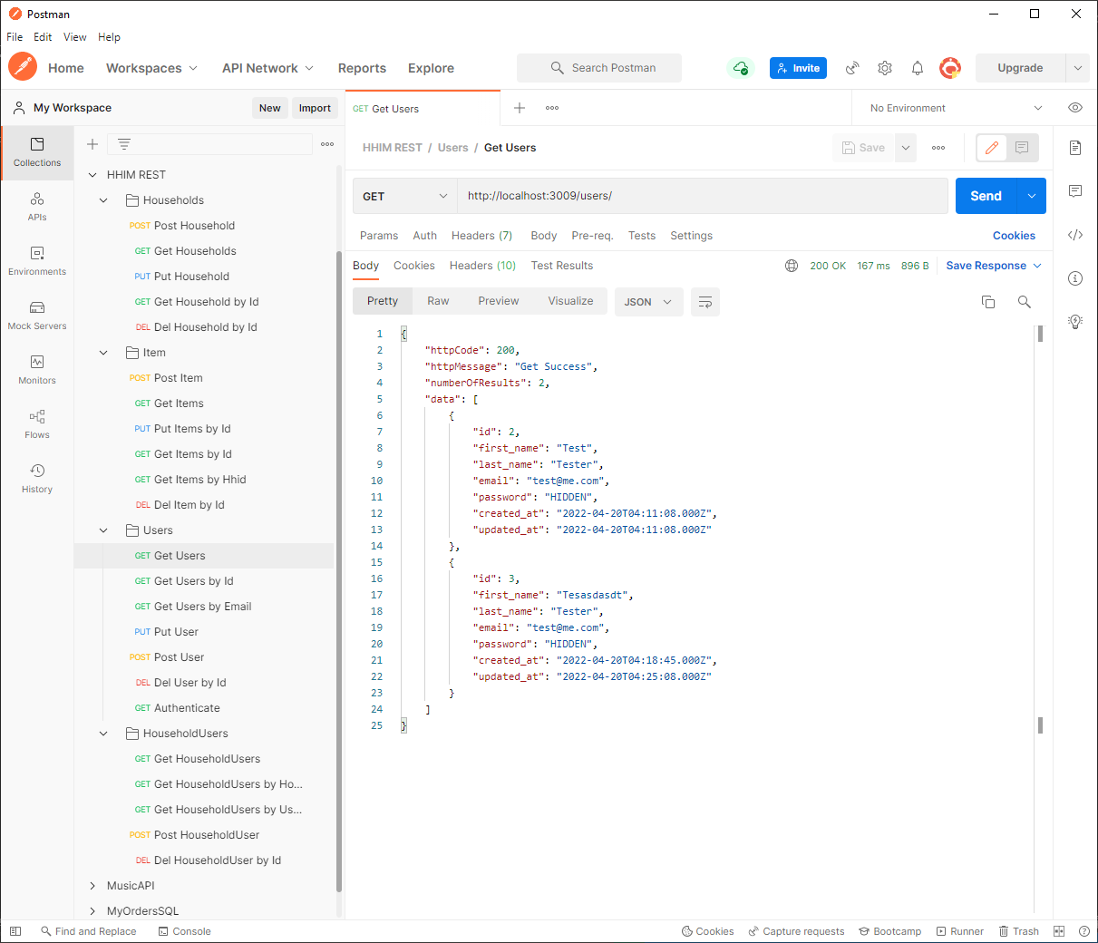

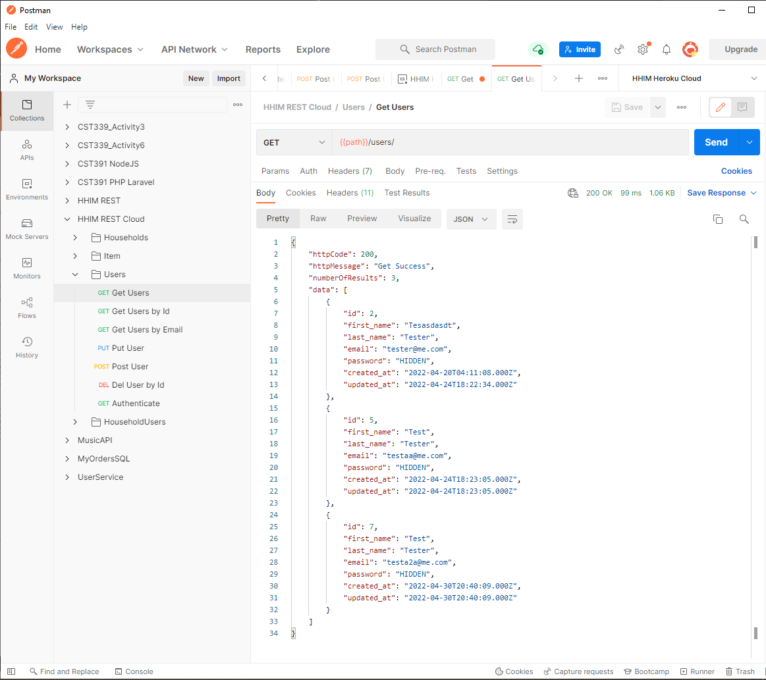

GET: Get User By Email

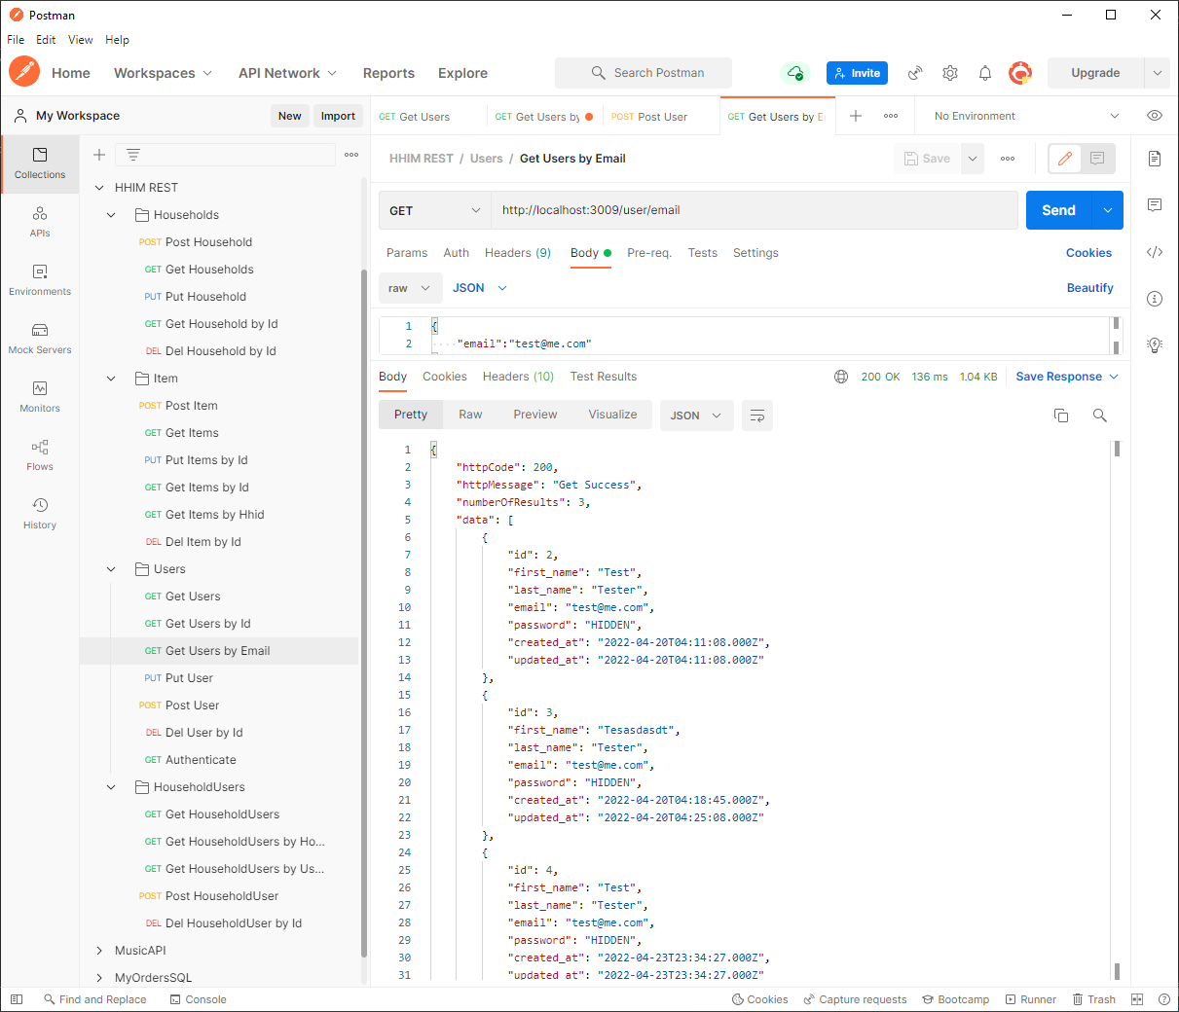

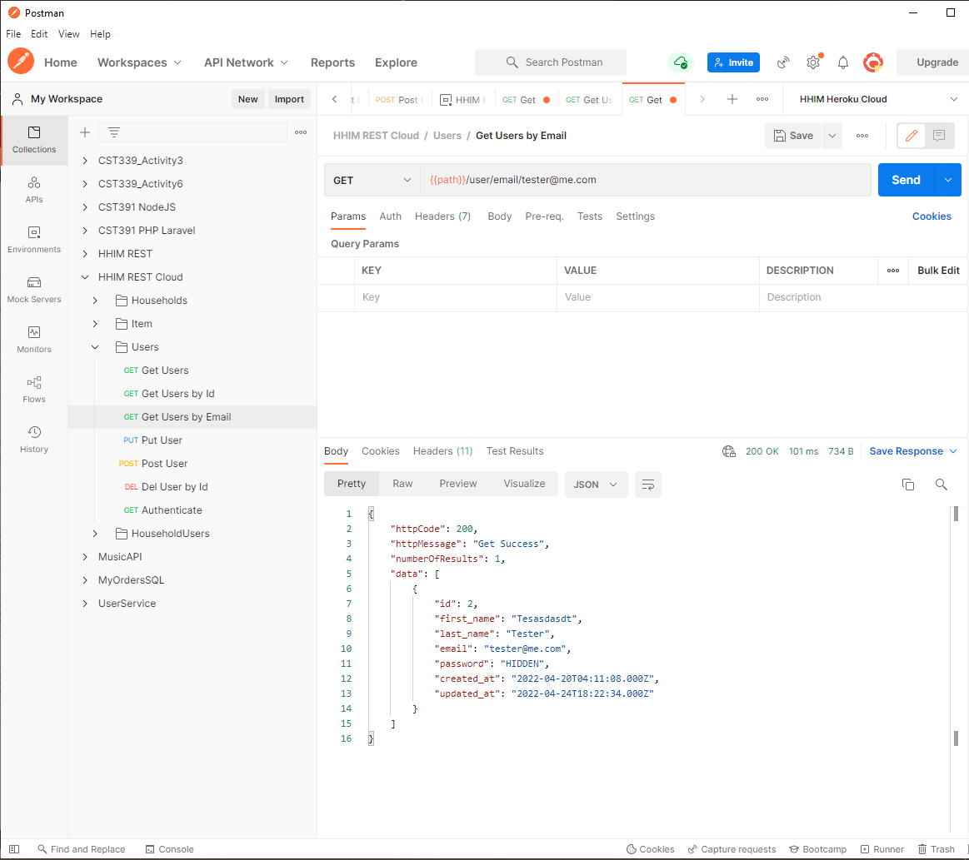

PUT: Update User

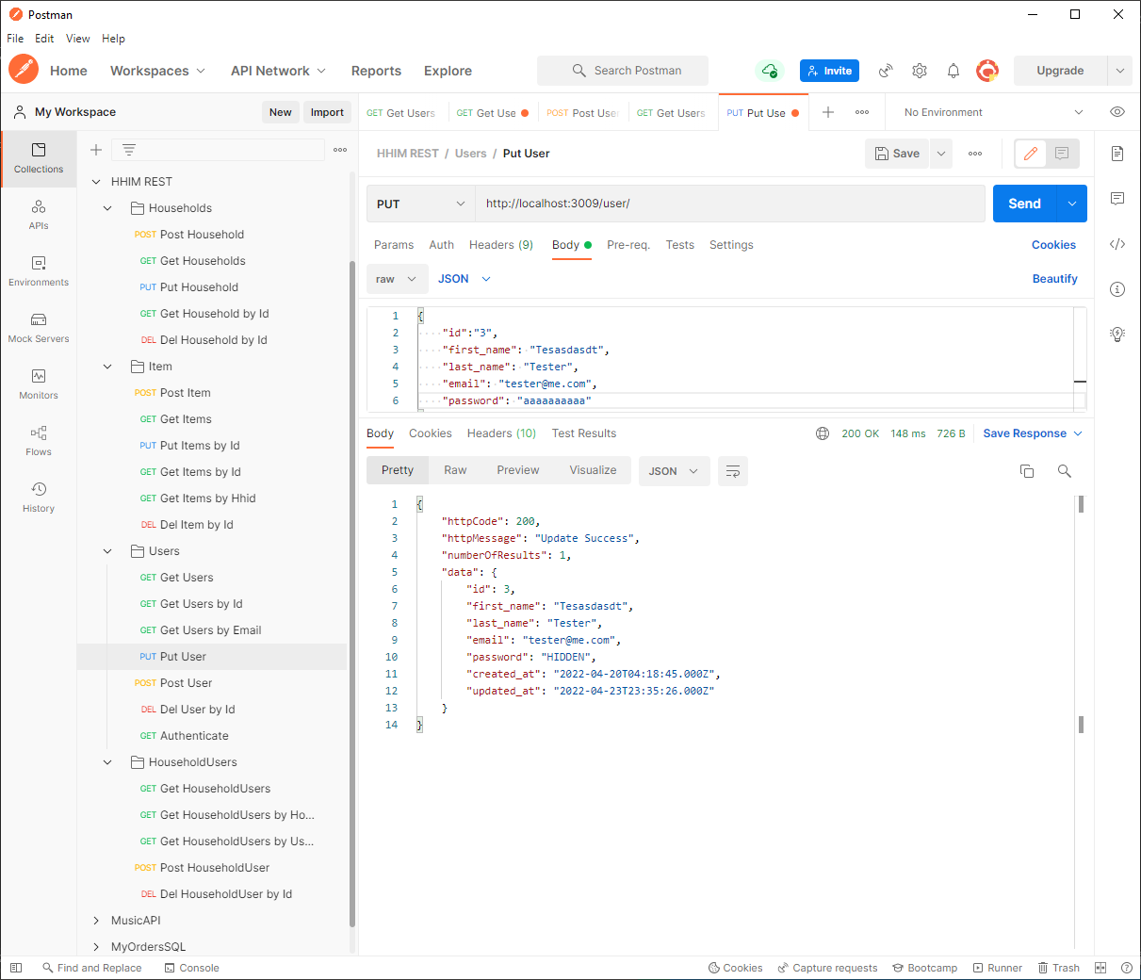

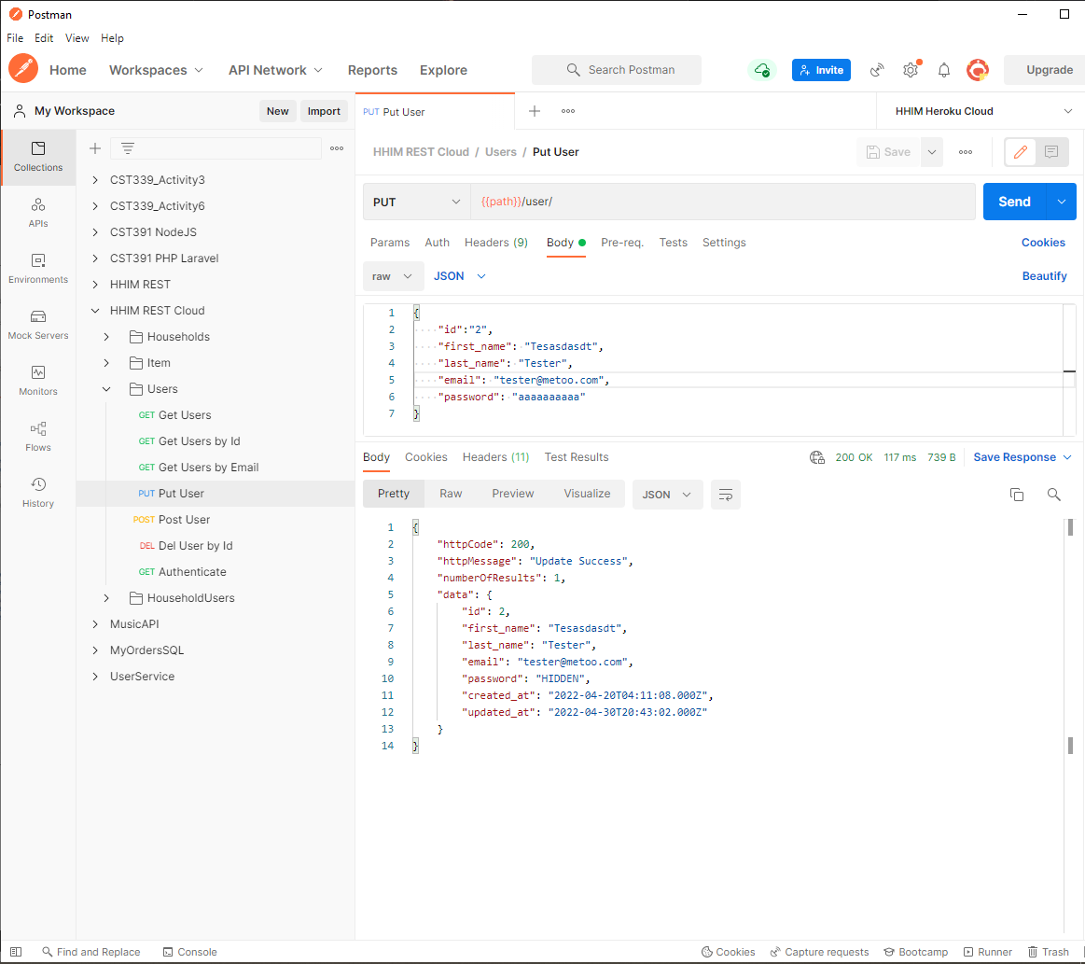

GET: Authenticate -> POST: Authenticate

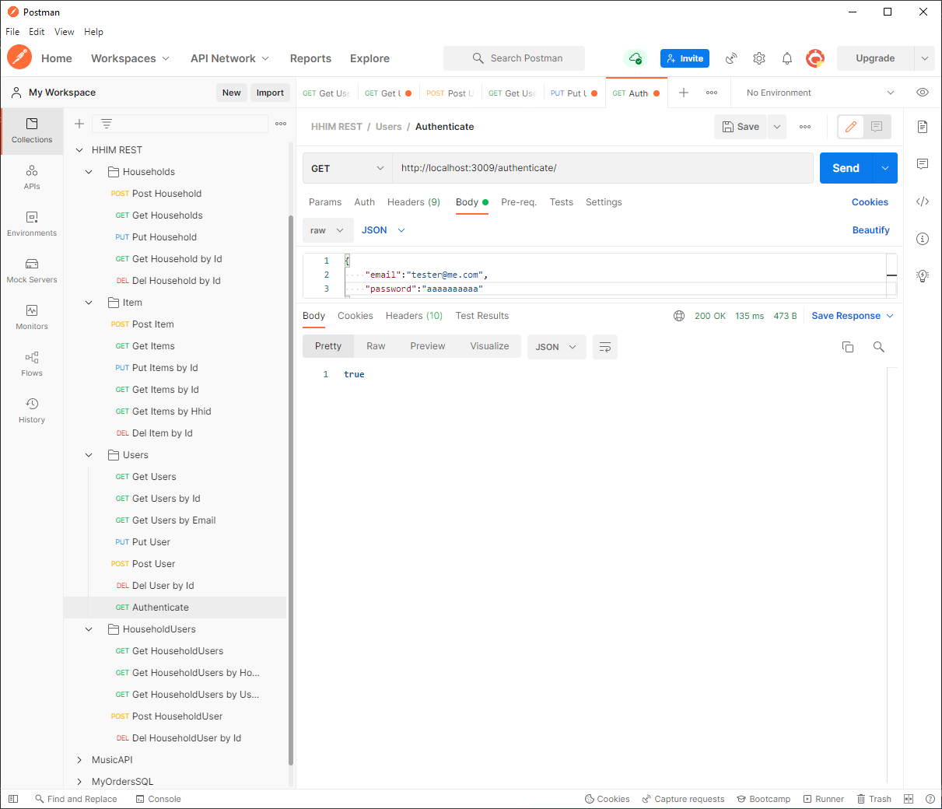

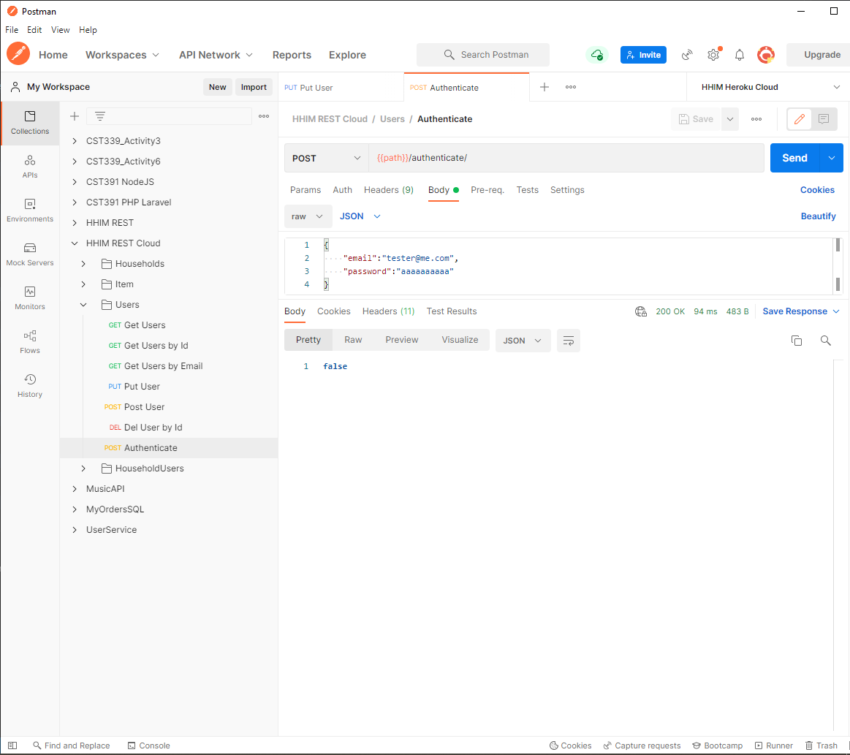

DELETE: Delete User

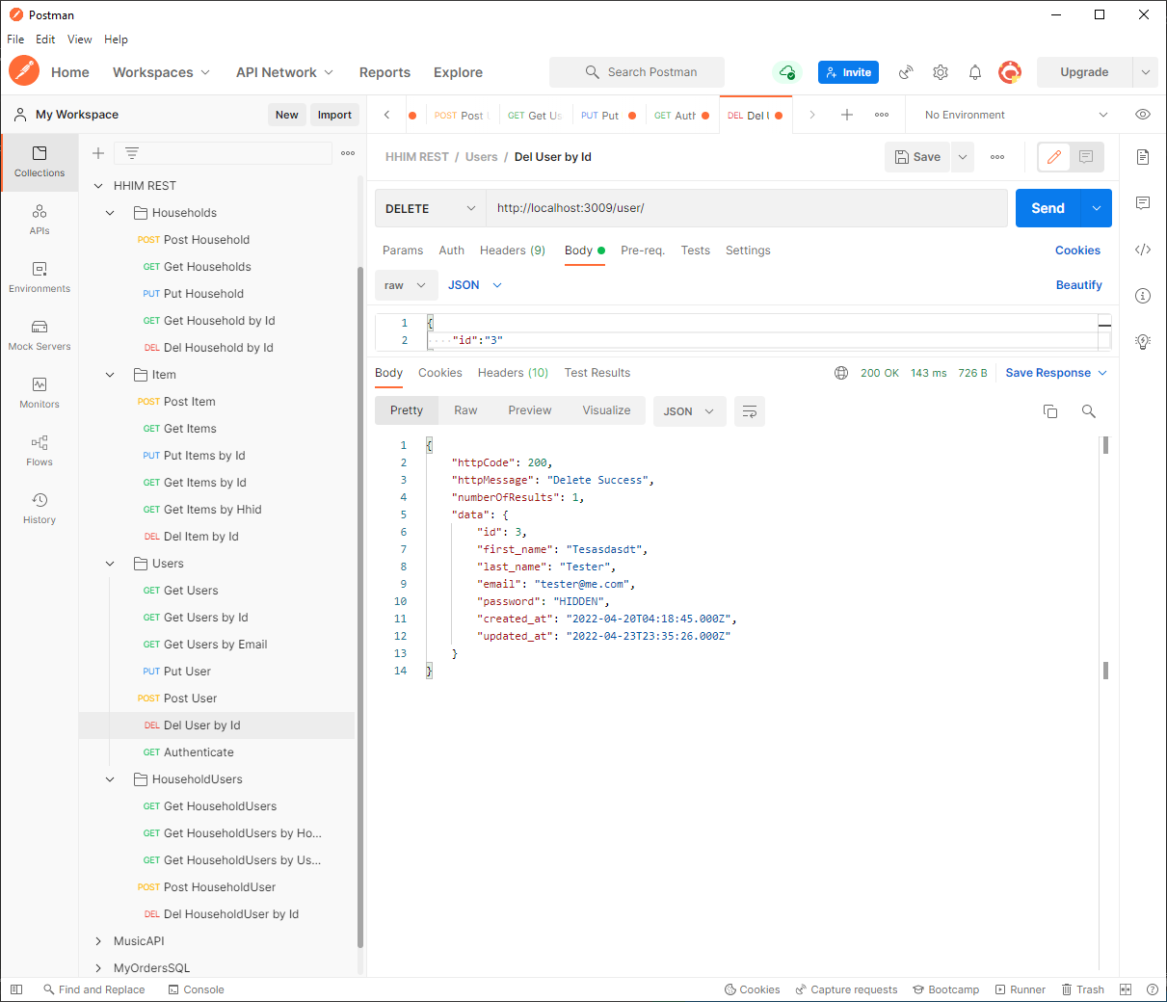

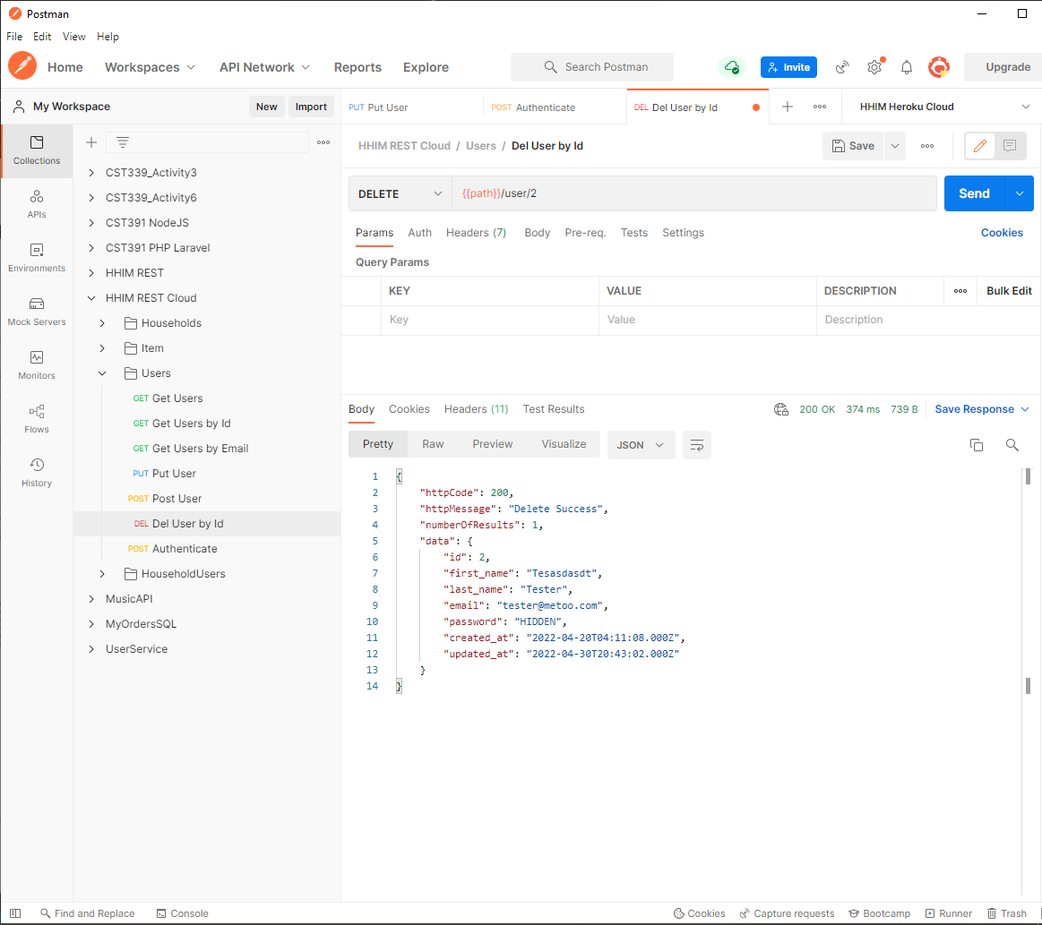

### Household Users:

GET: Get Householdusers

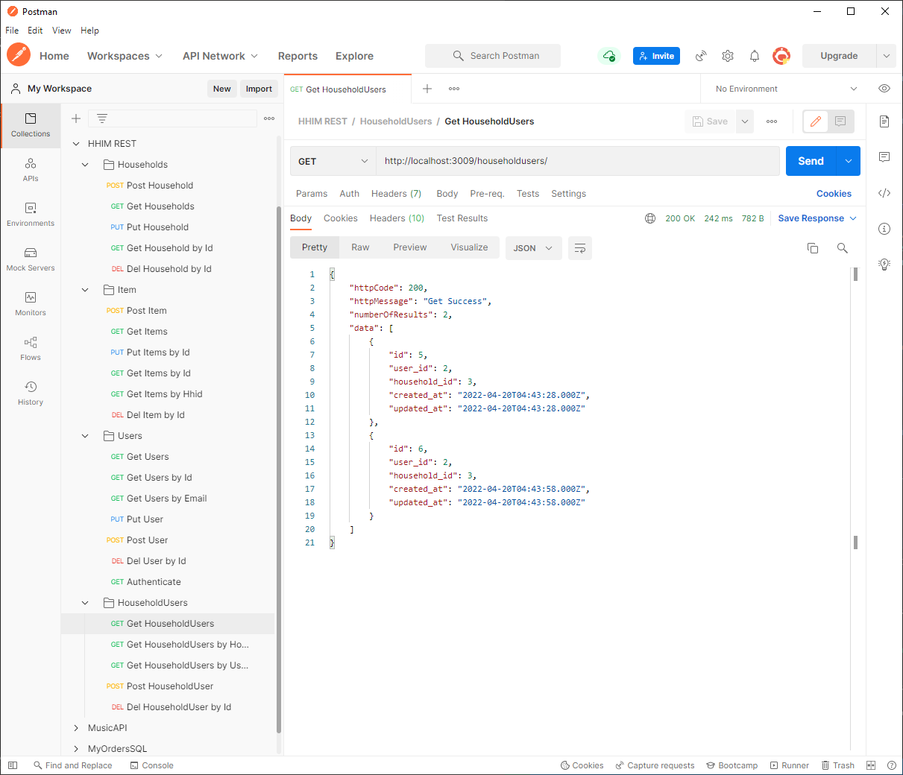

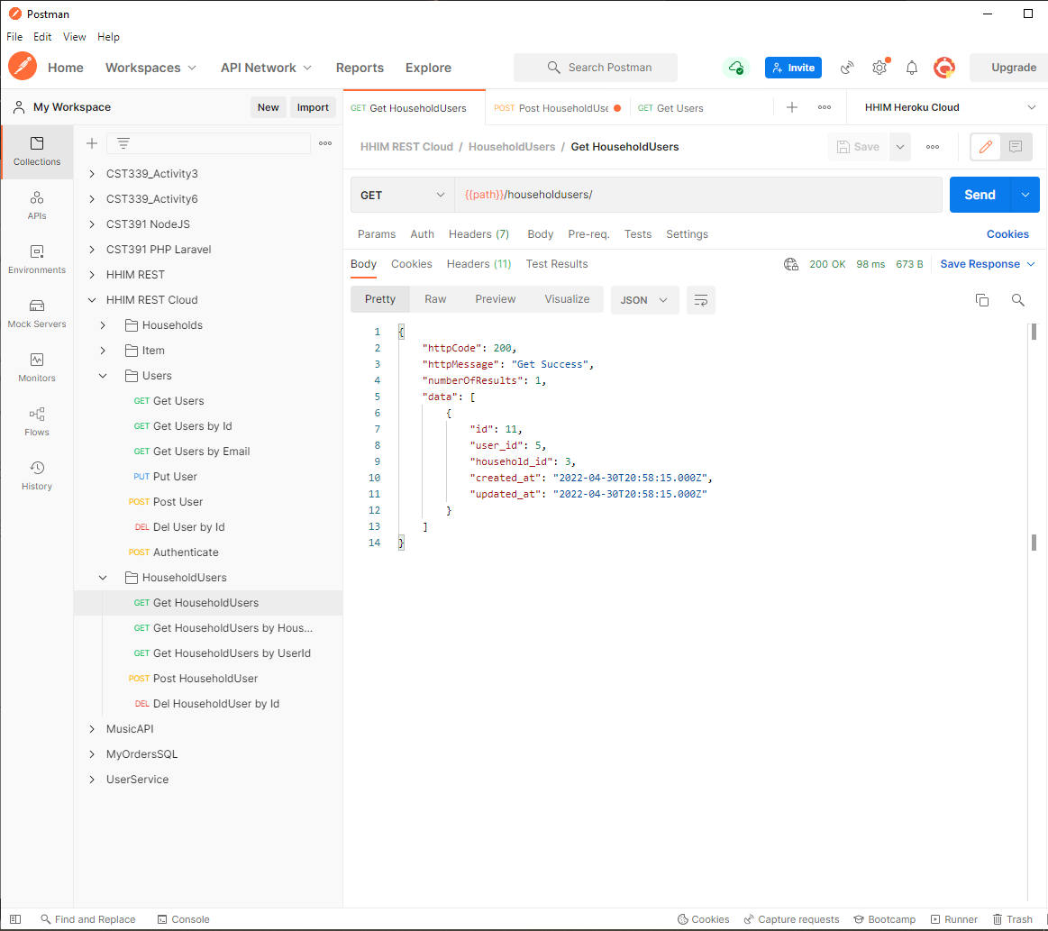

GET: Get Users by Household ID

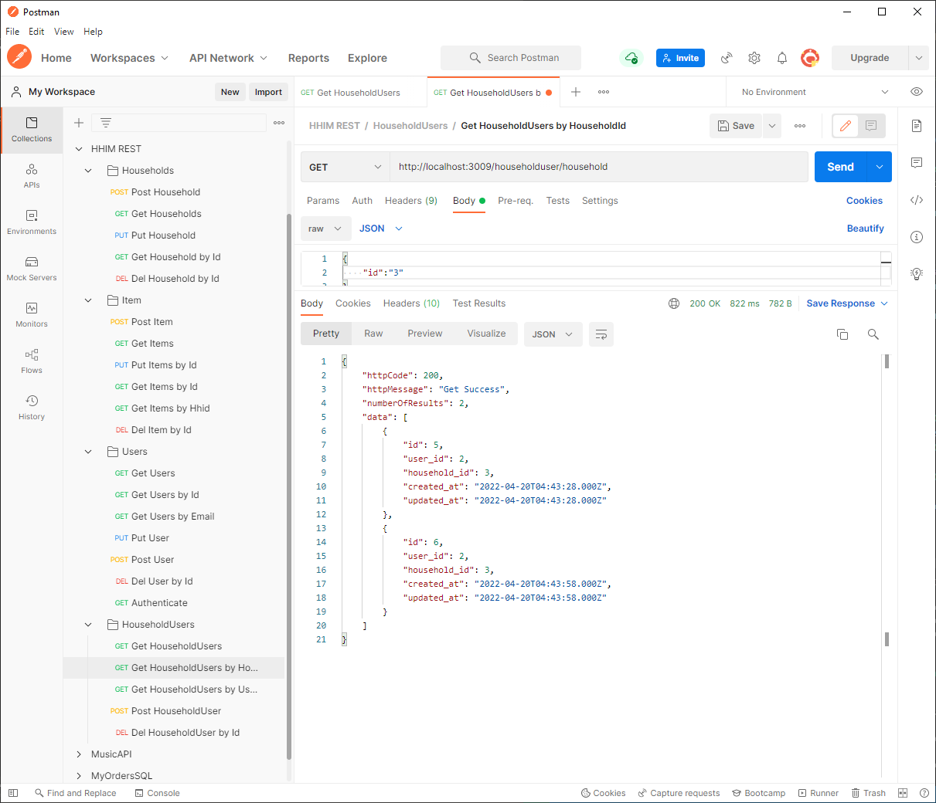

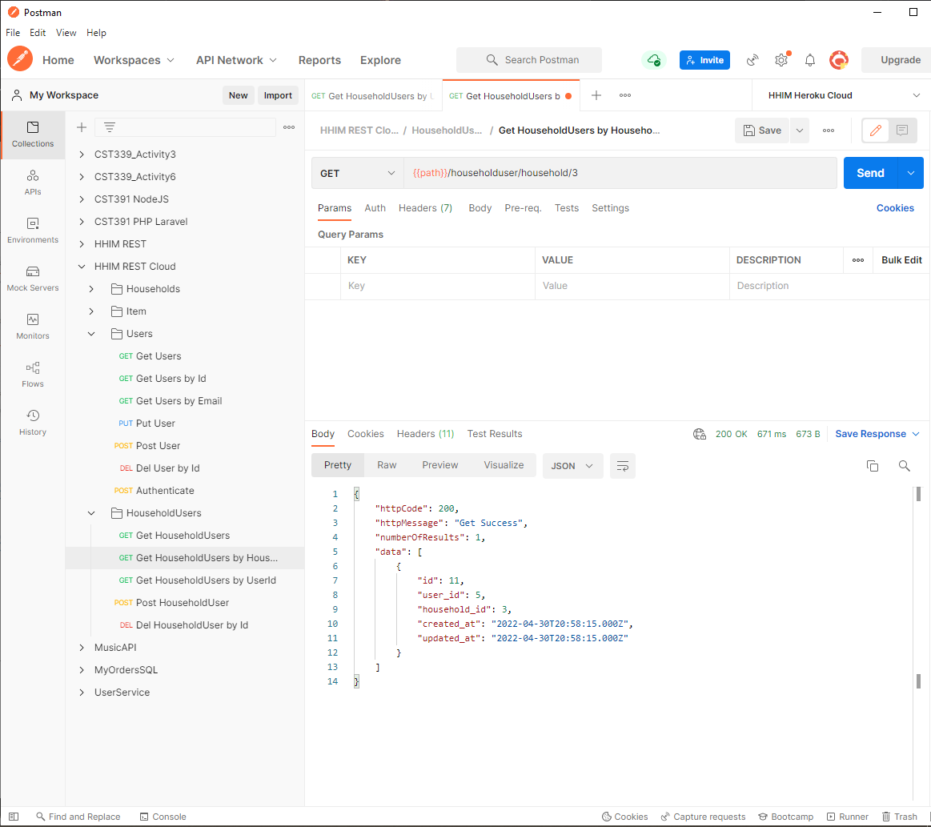

GET: Get Households by User ID

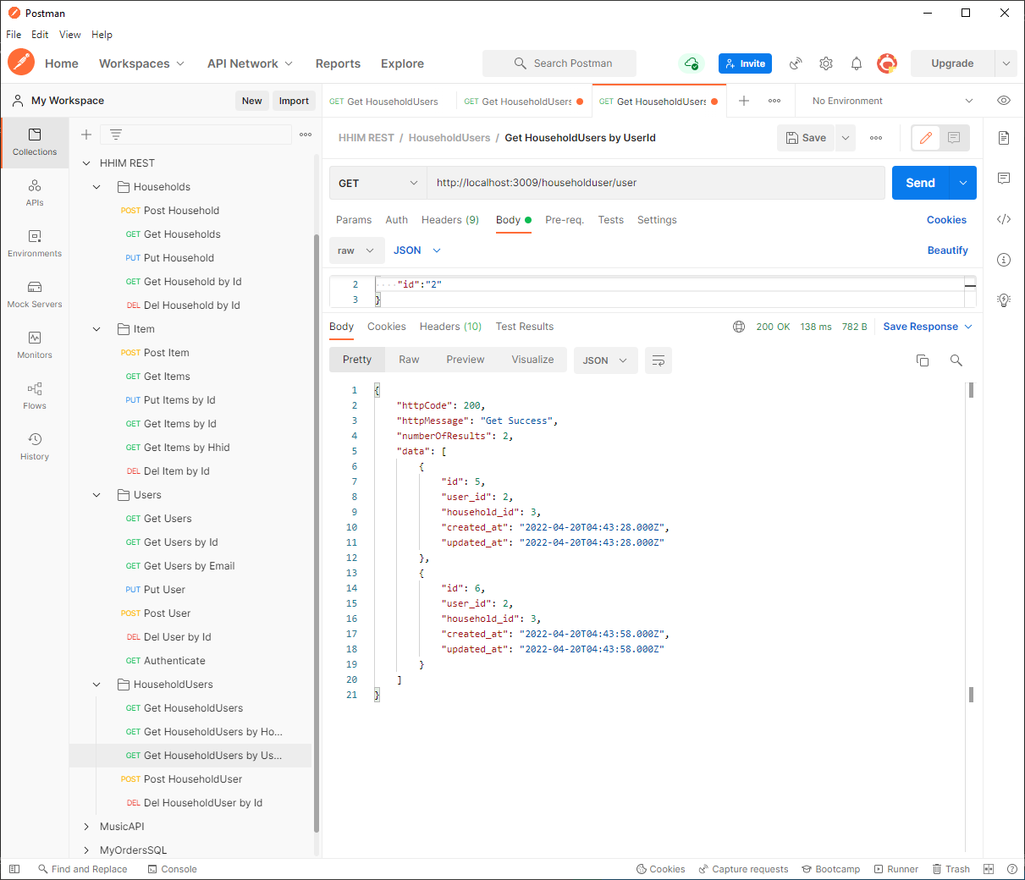

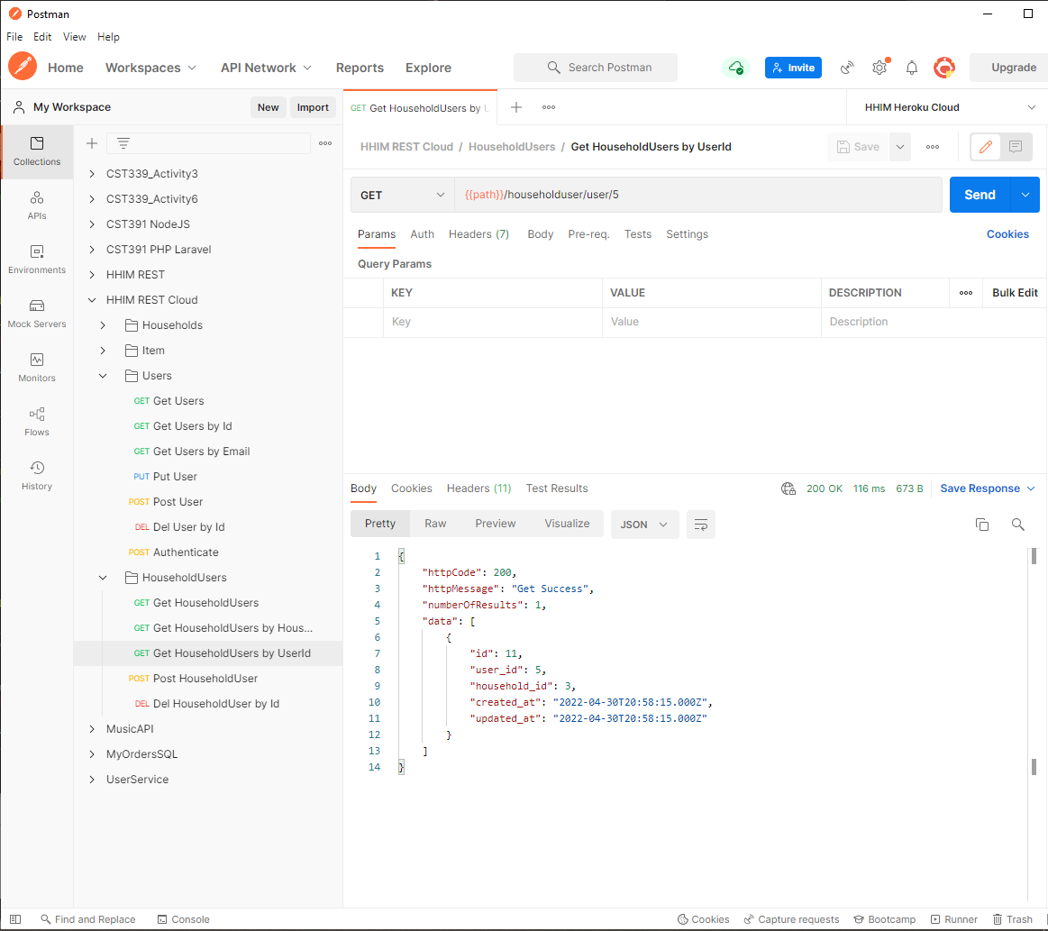

POST: Create Household User

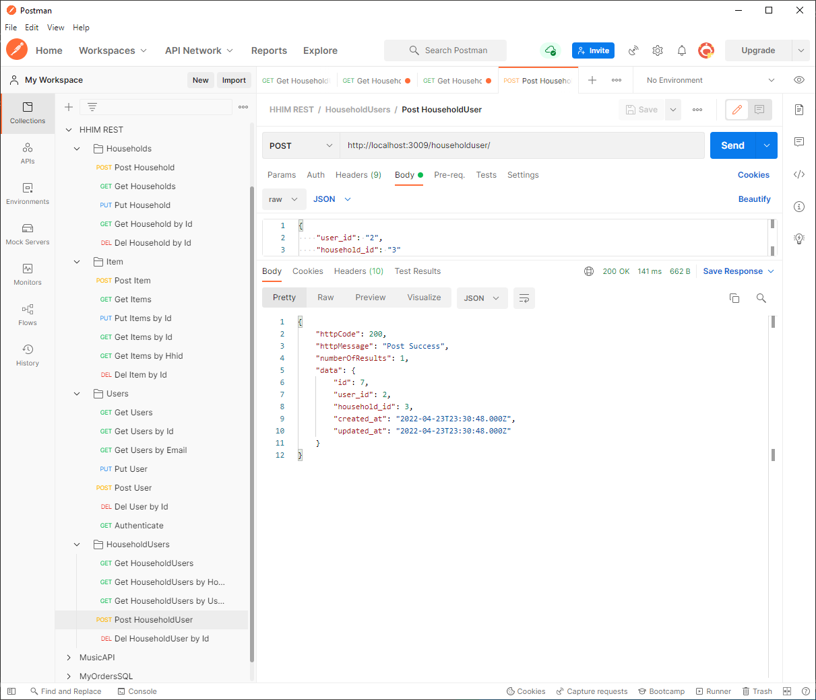

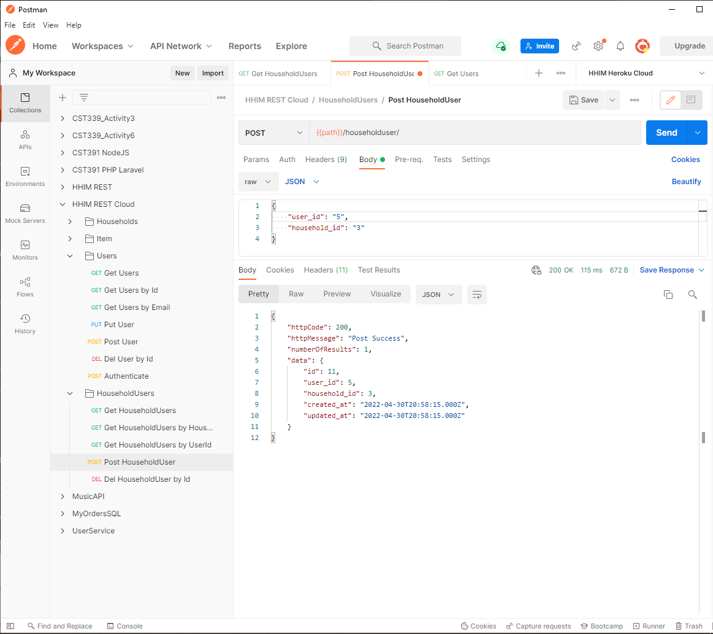

DELETE: Delete Household User

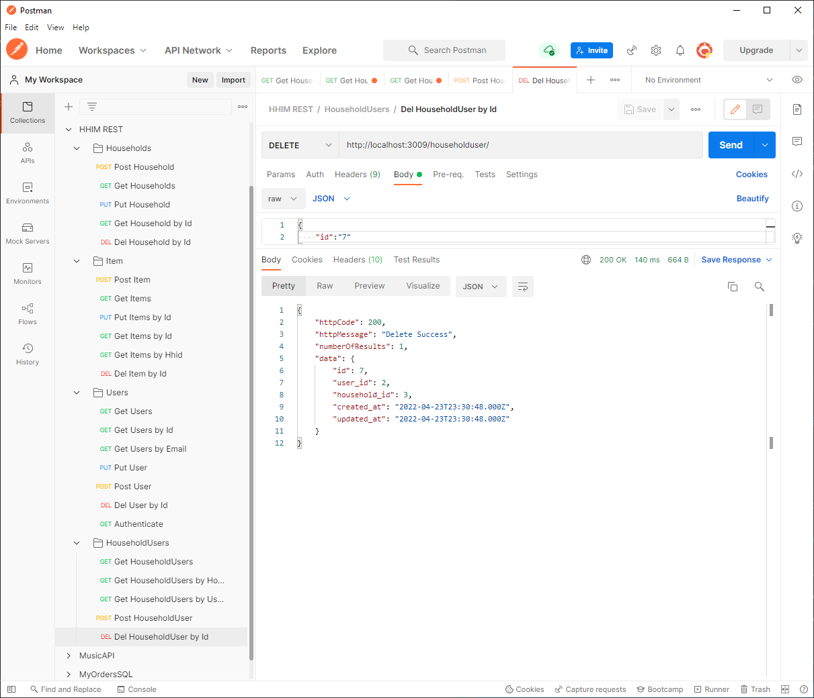

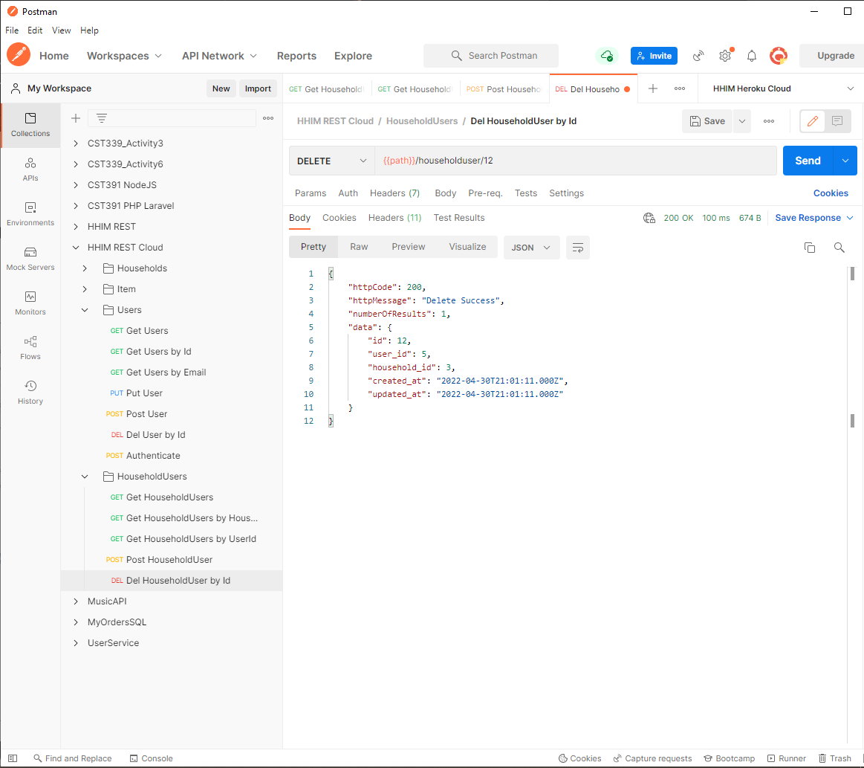

### Households:

POST: Create Household

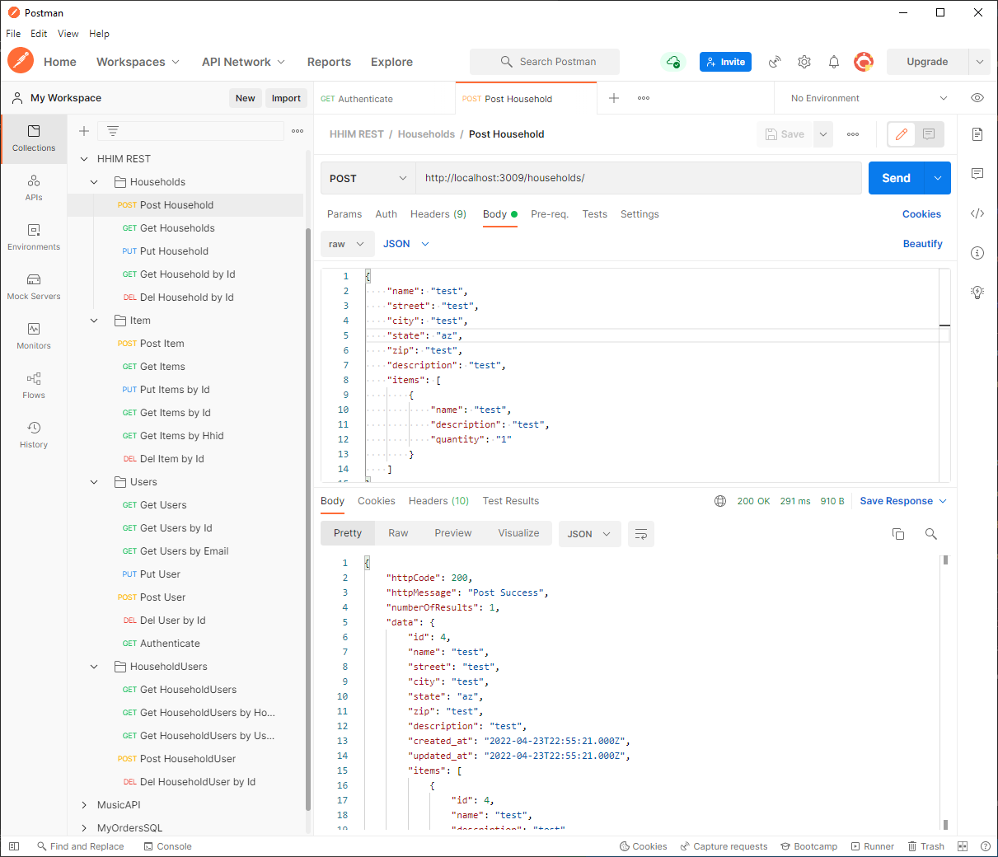

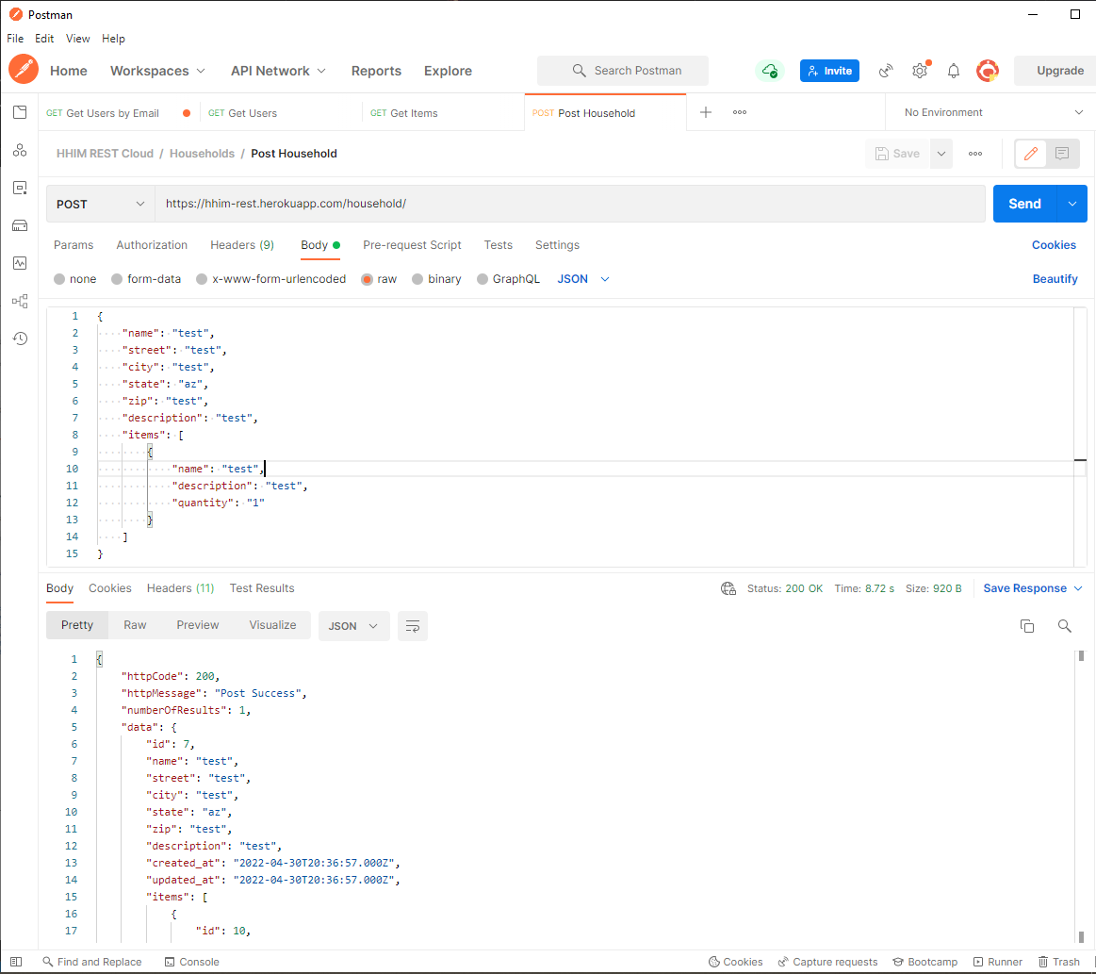

GET: Get Households

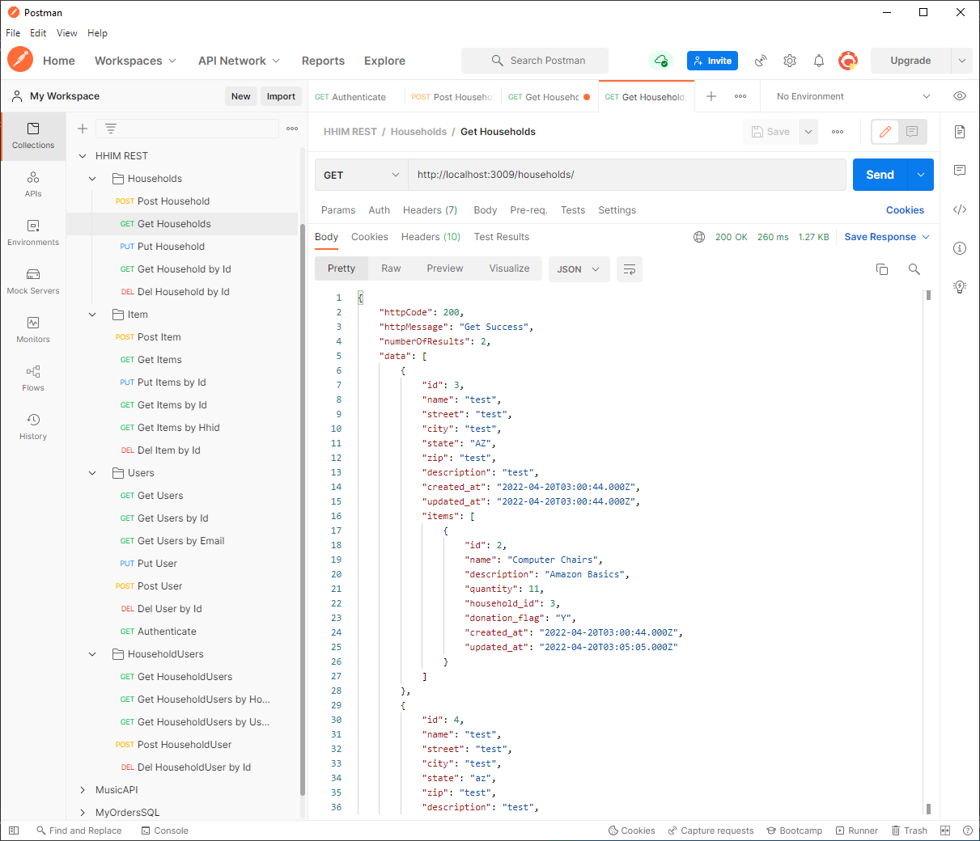

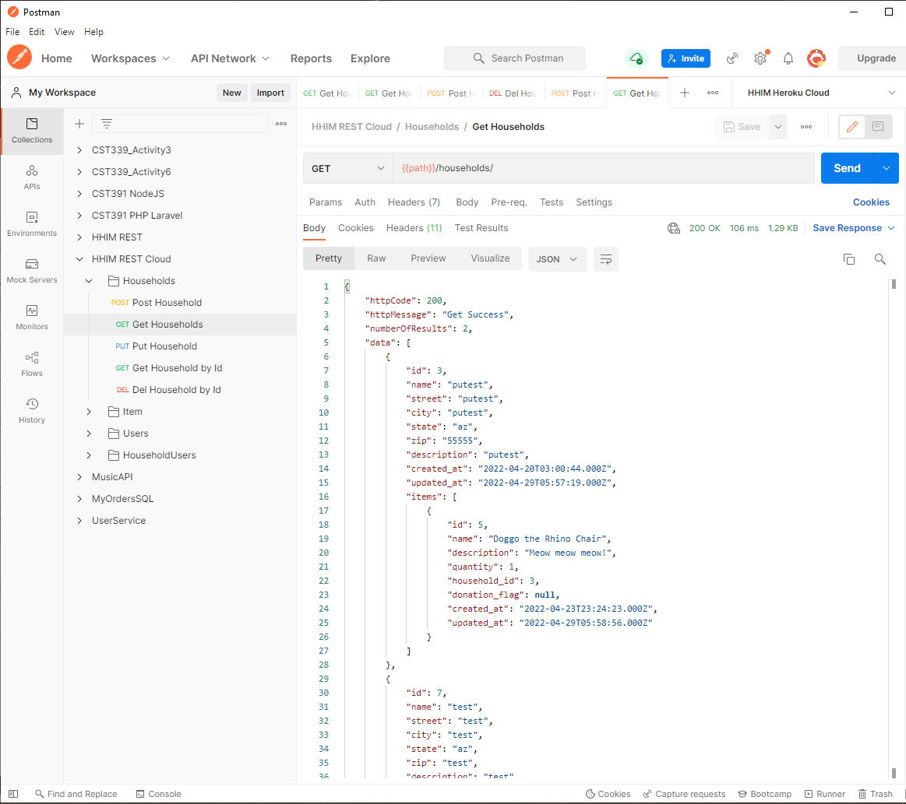

GET Households by User ID

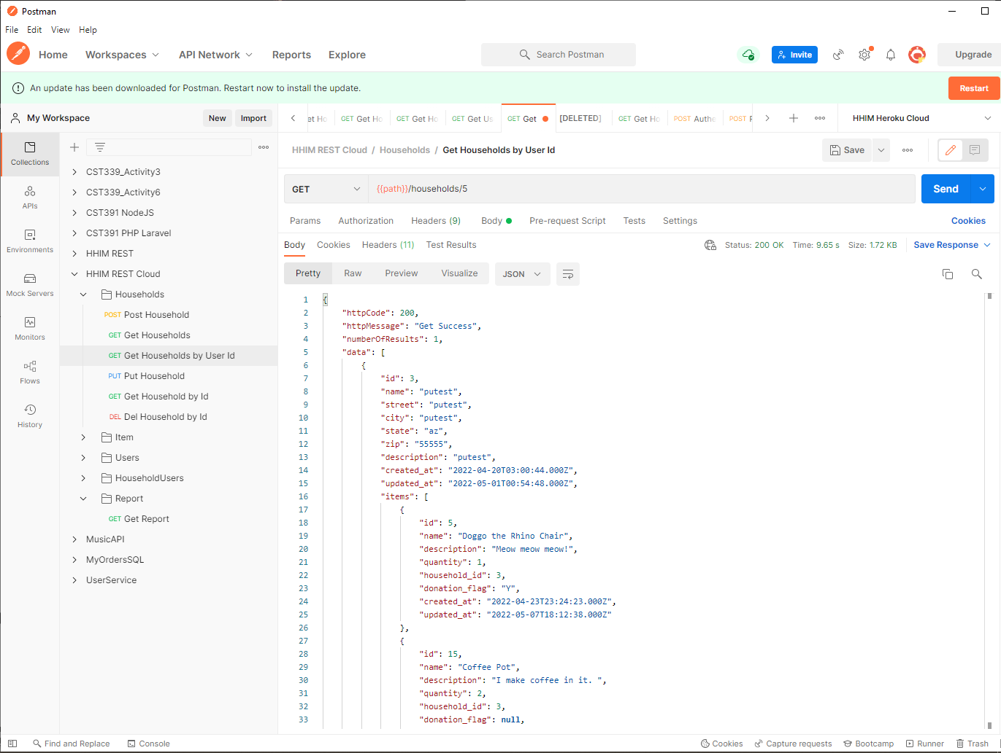

GET: Get Household By ID

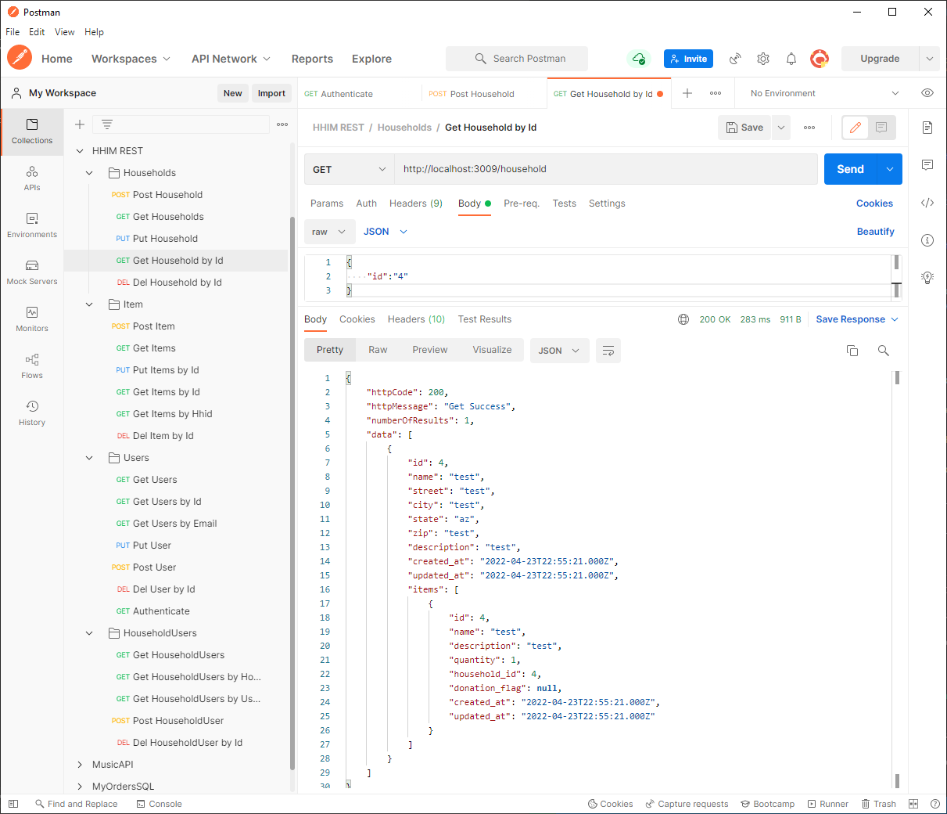

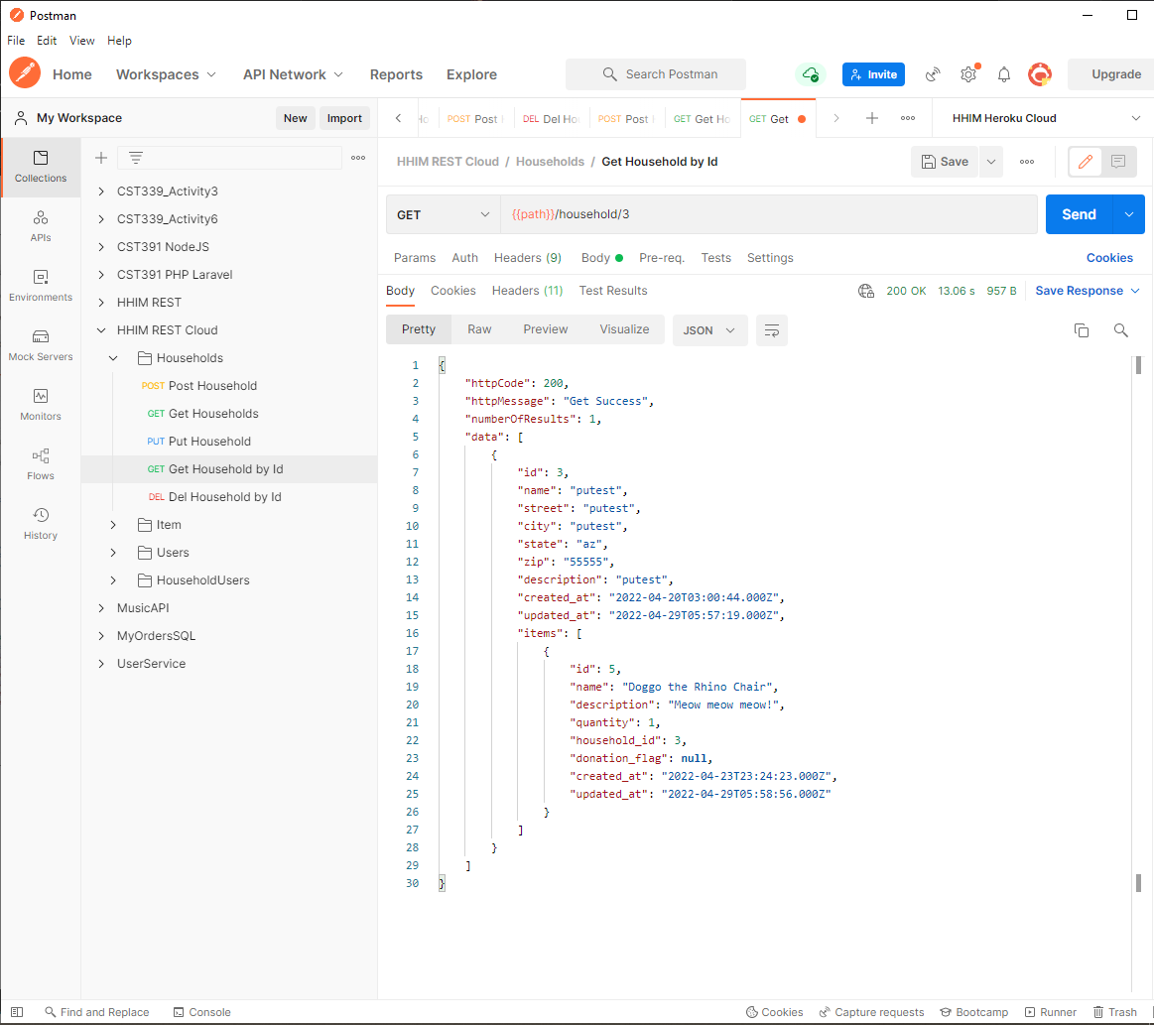

DEL: Delete Household

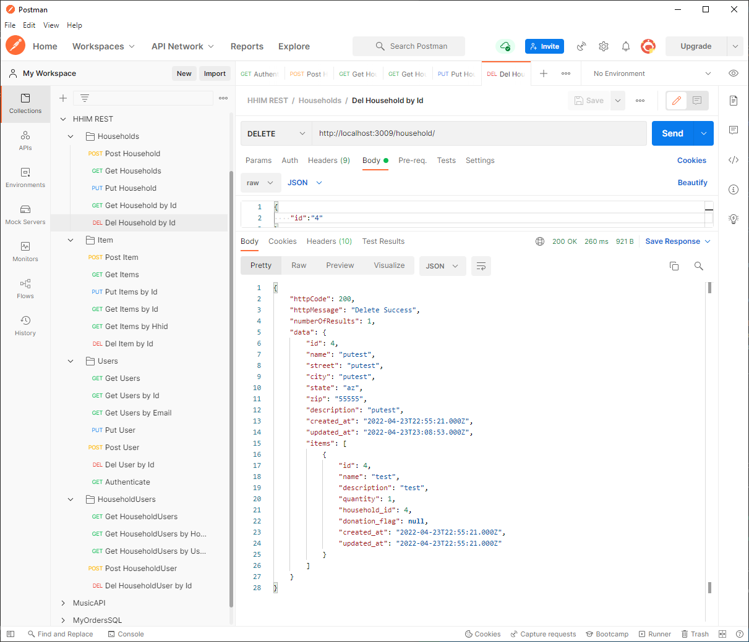

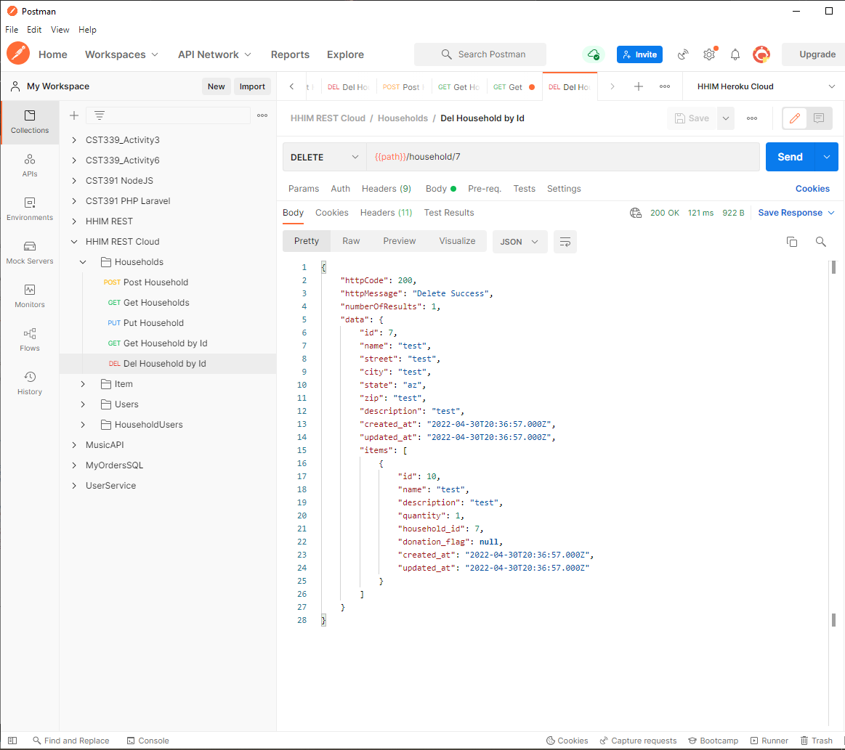

PUT: Update Household

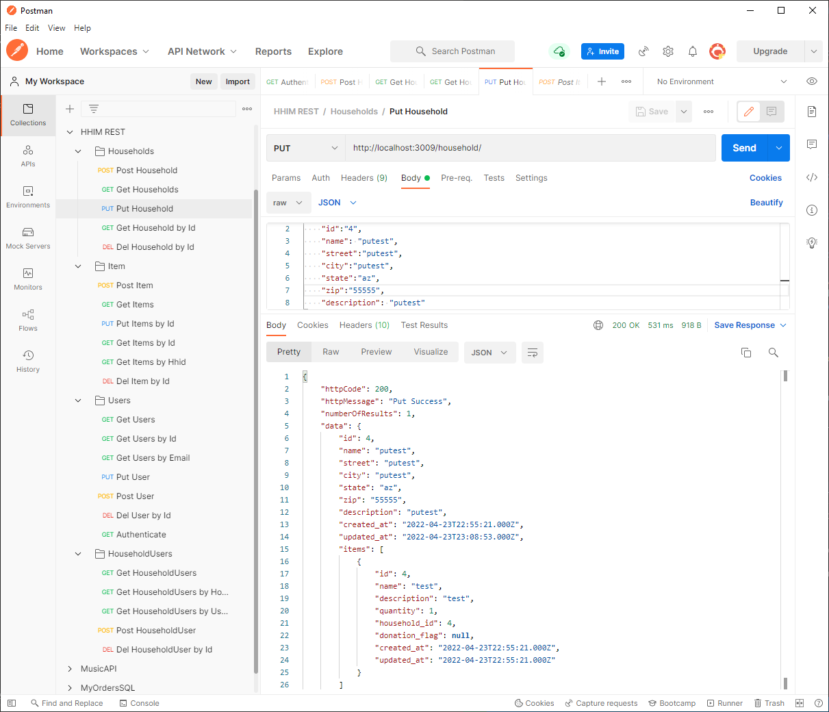

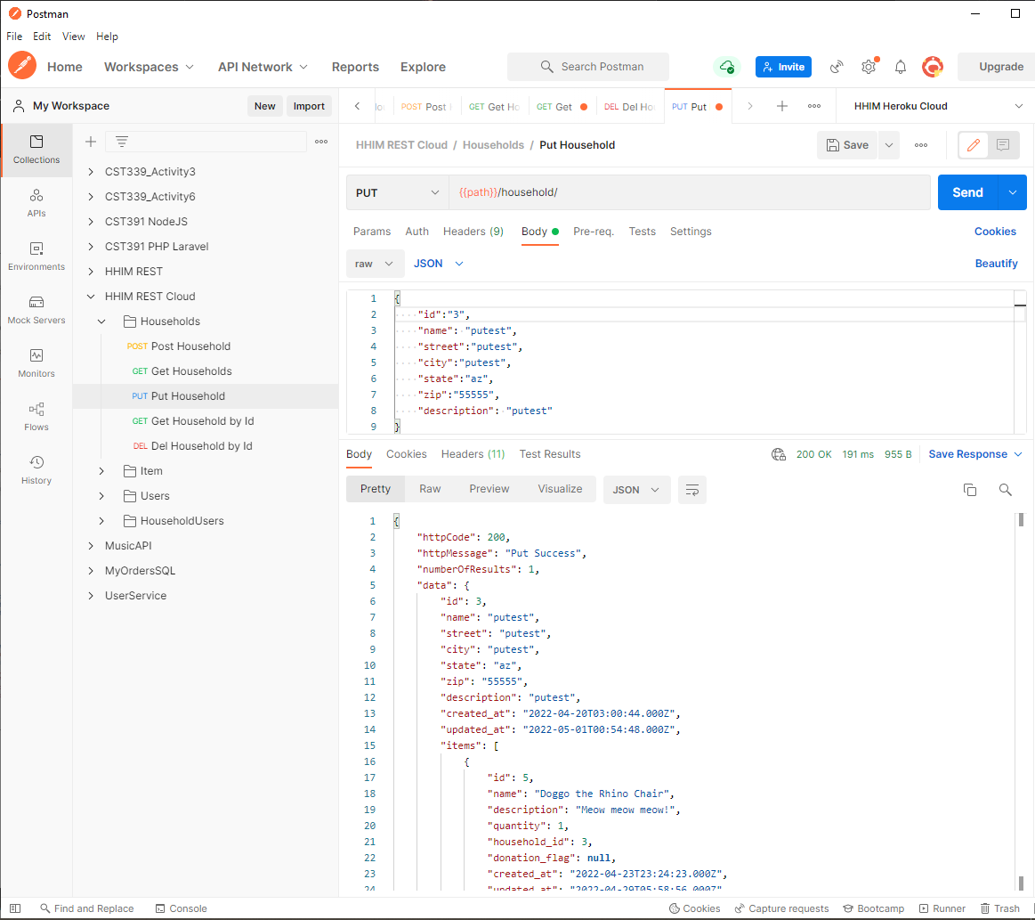

### Items:

POST: Create Item

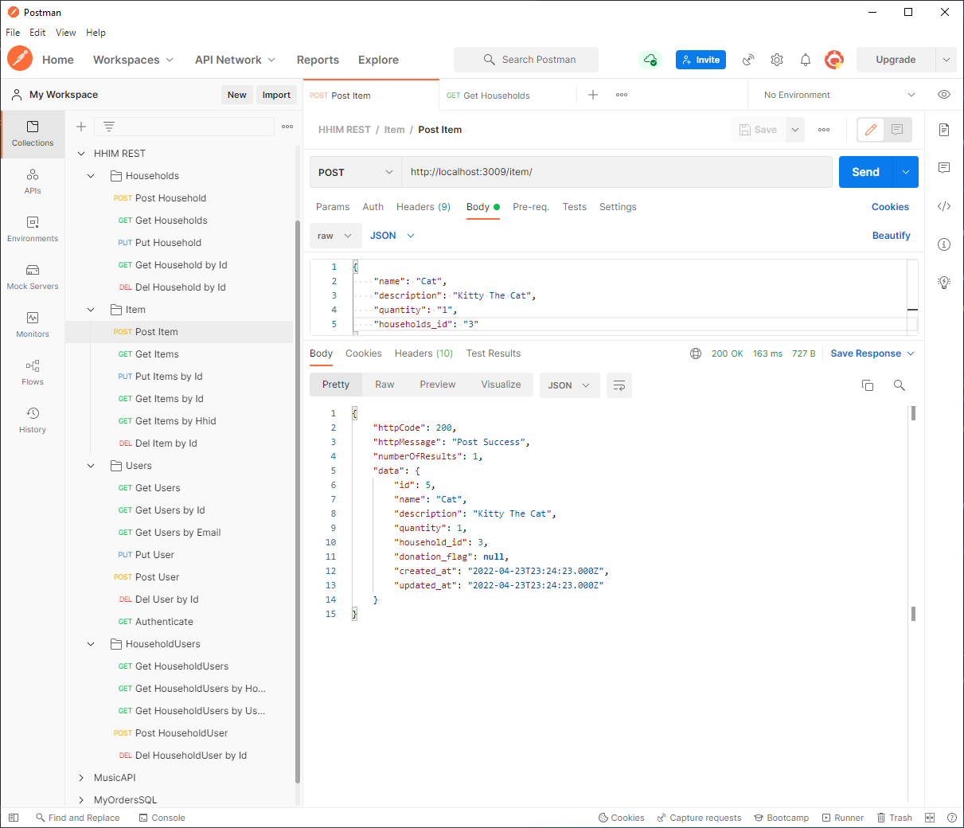

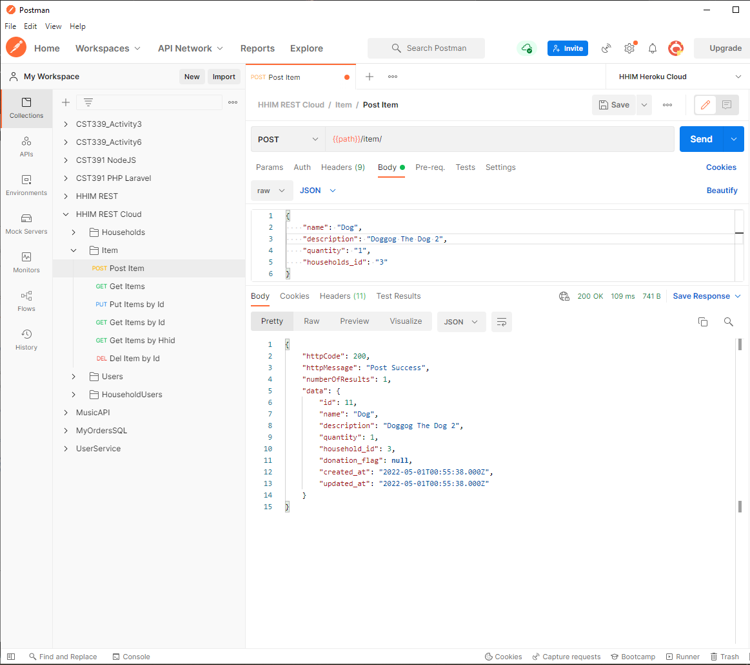

GET: Get Items

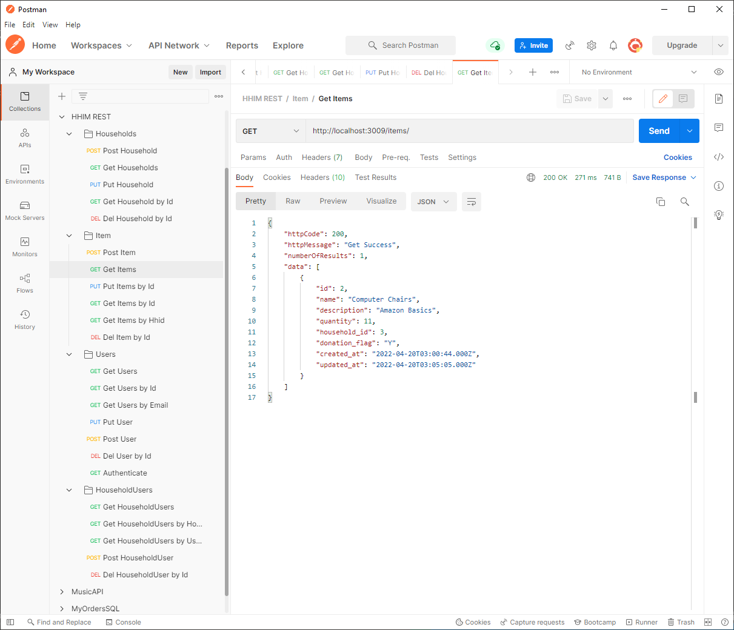

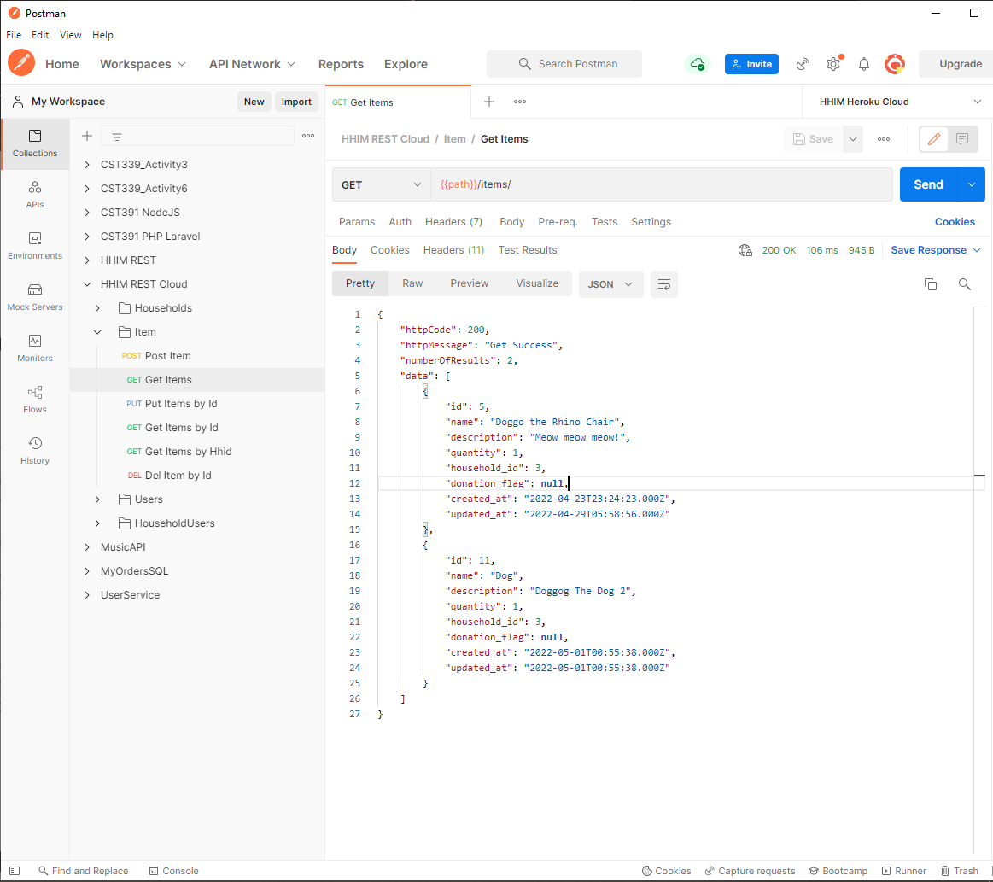

GET: Get Item By ID

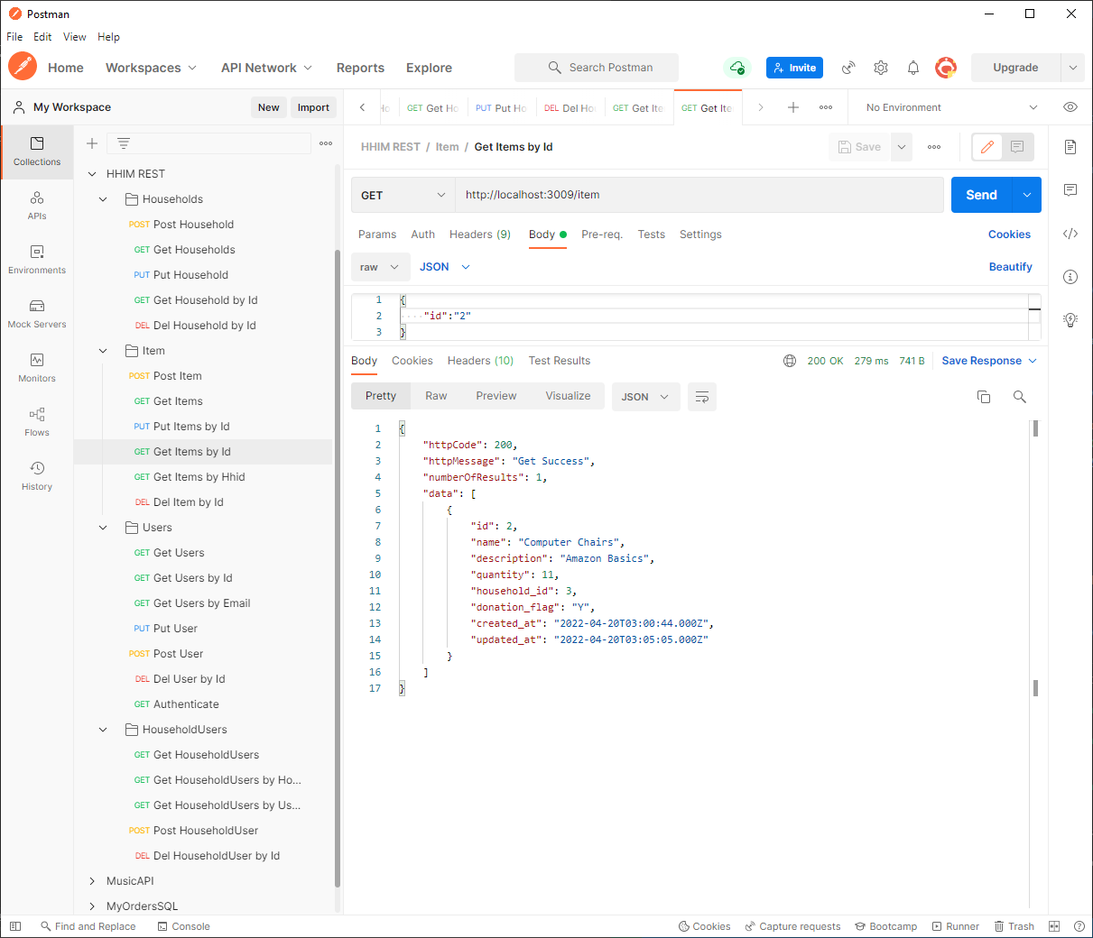

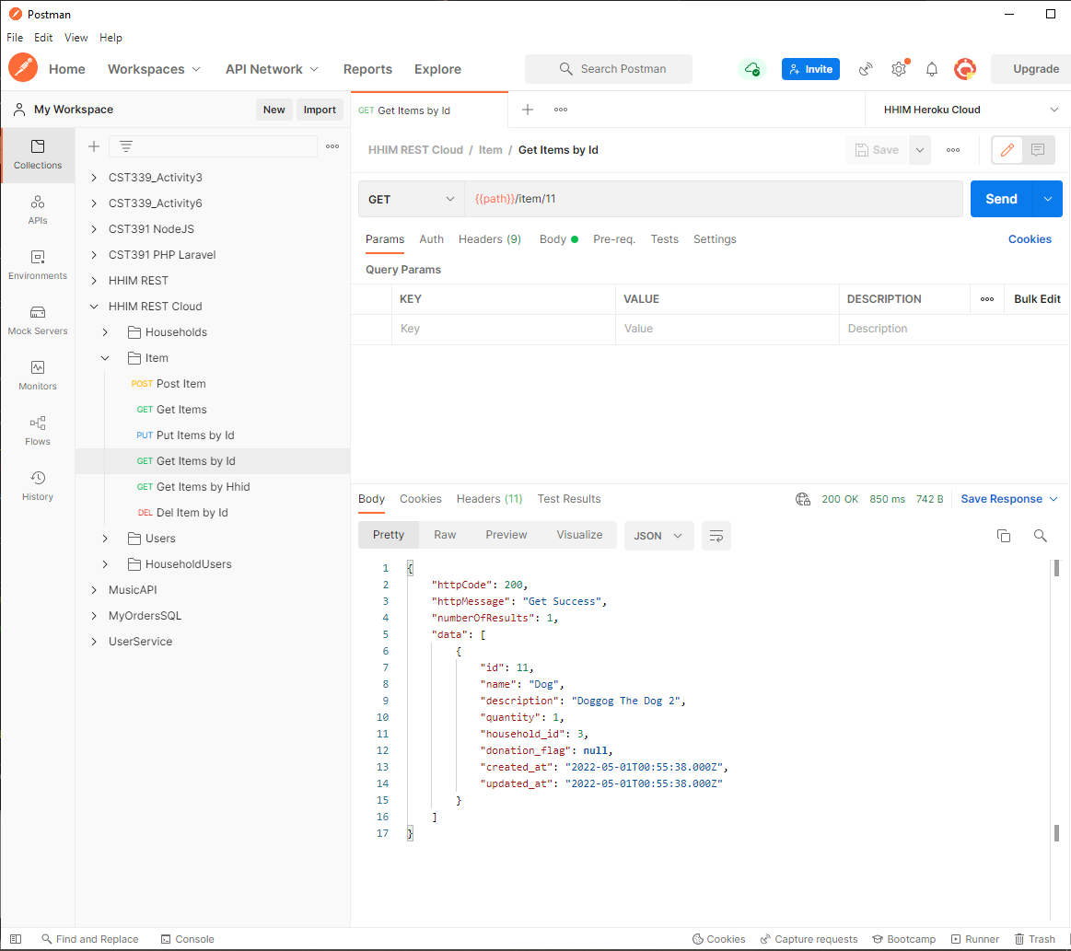

GET: Get Items By Household ID

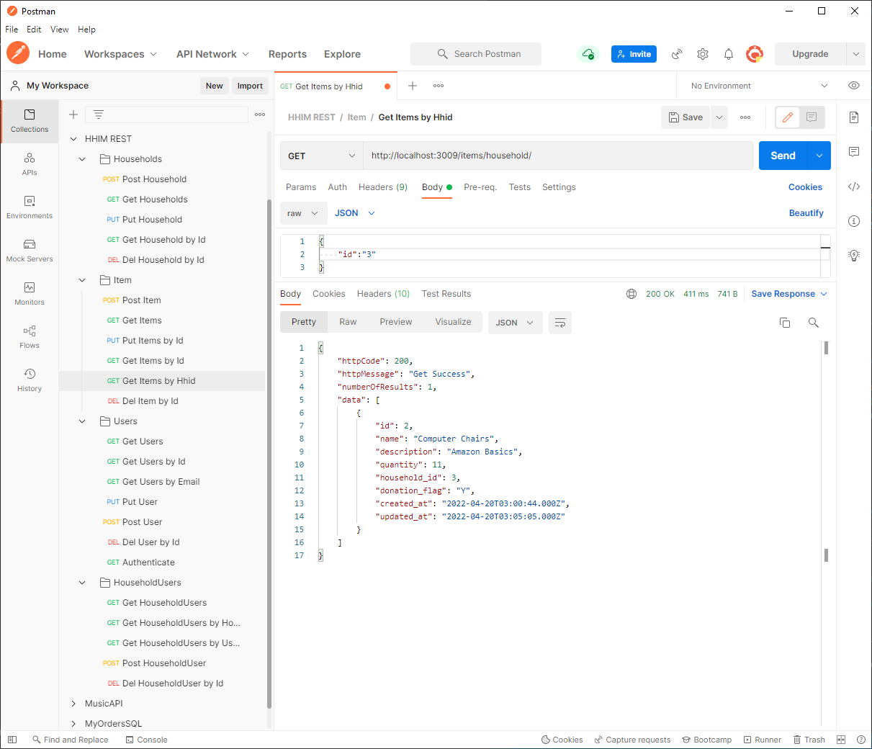

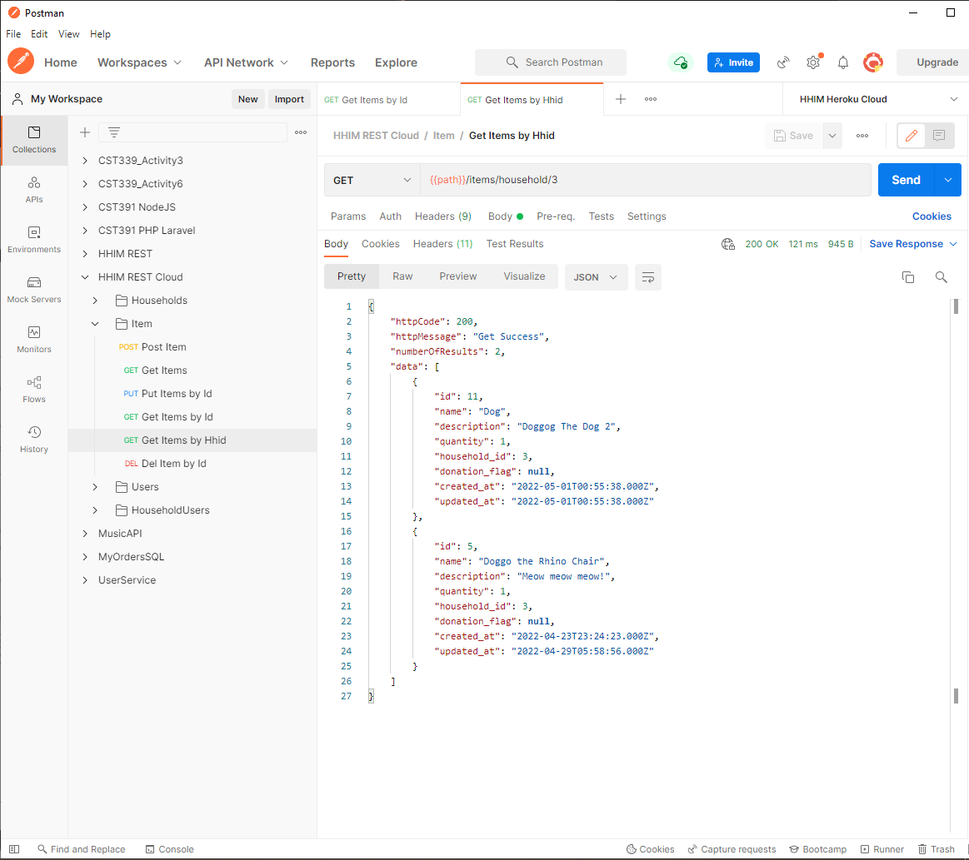

PUT: Update Item

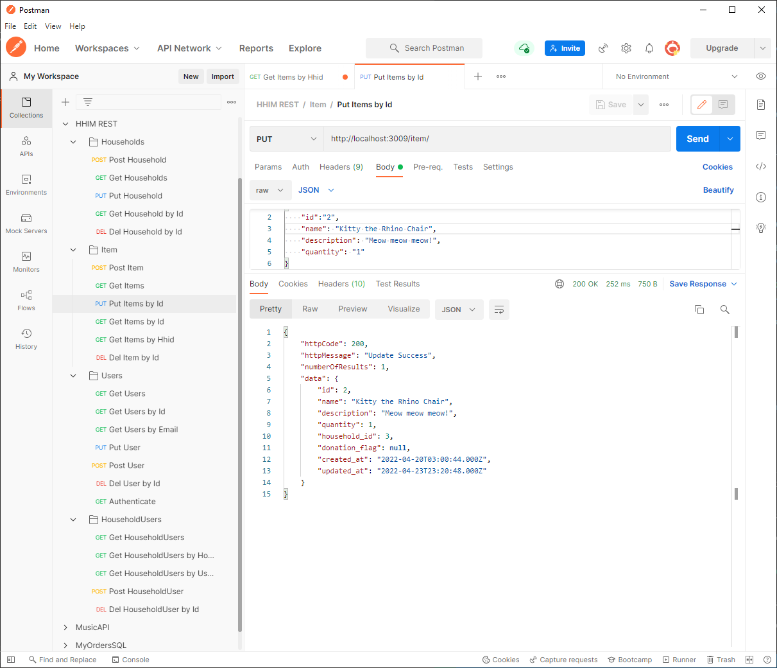

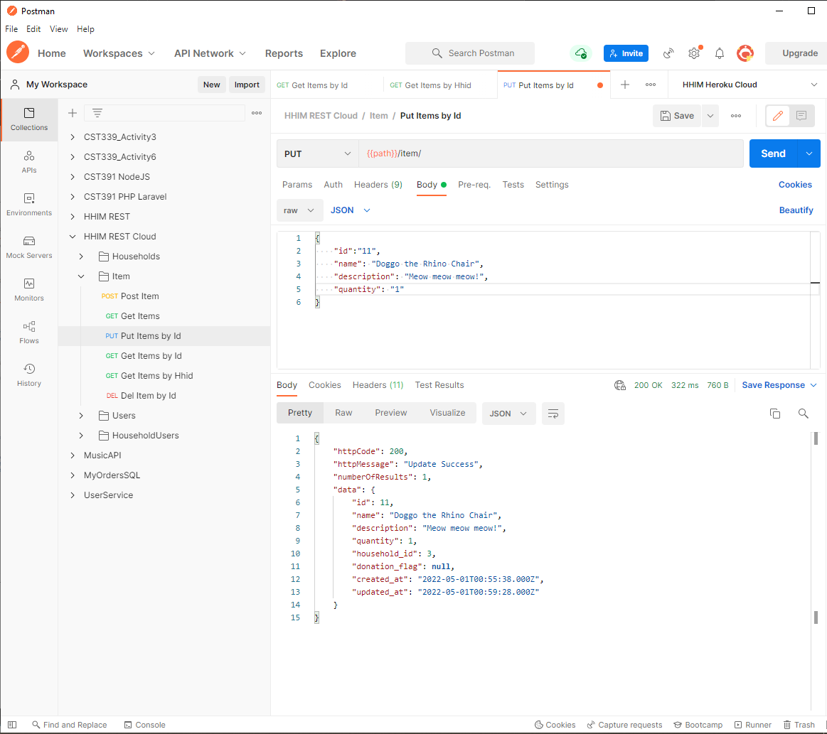

DEL: Delete Item

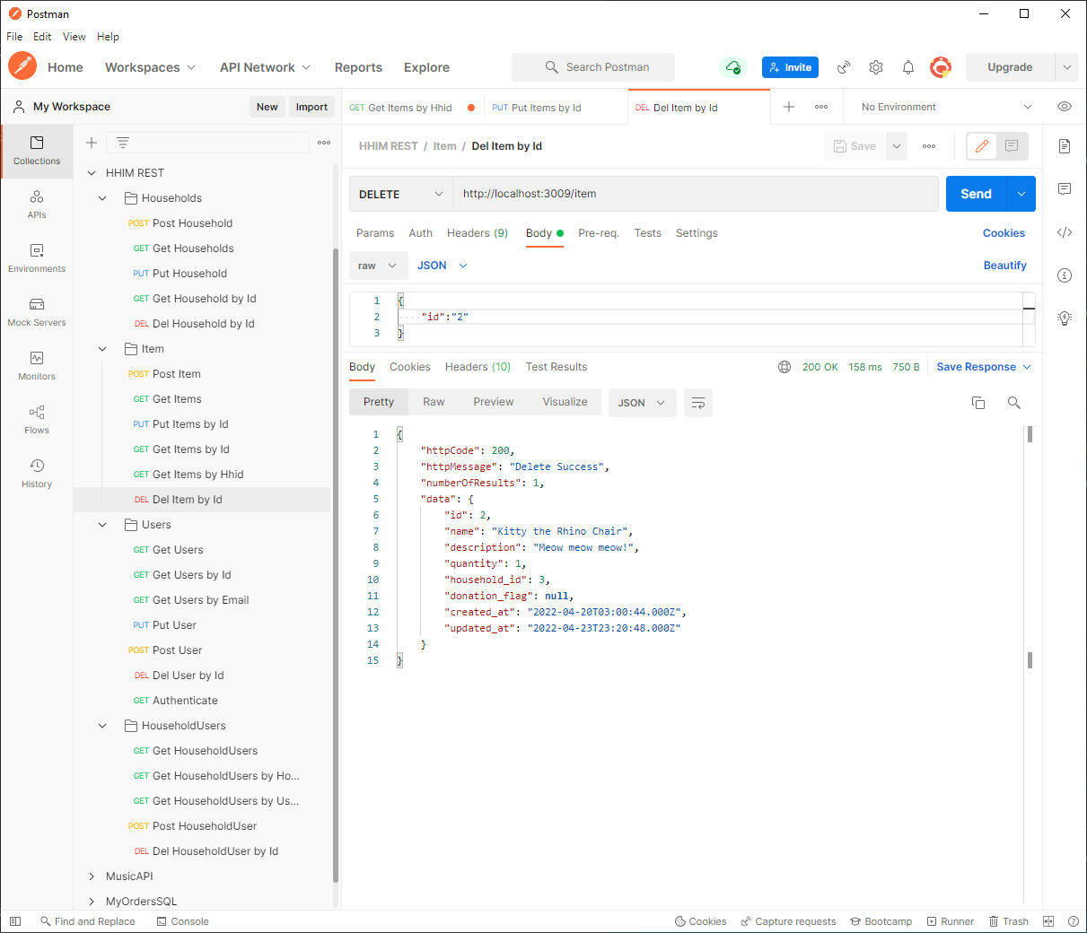

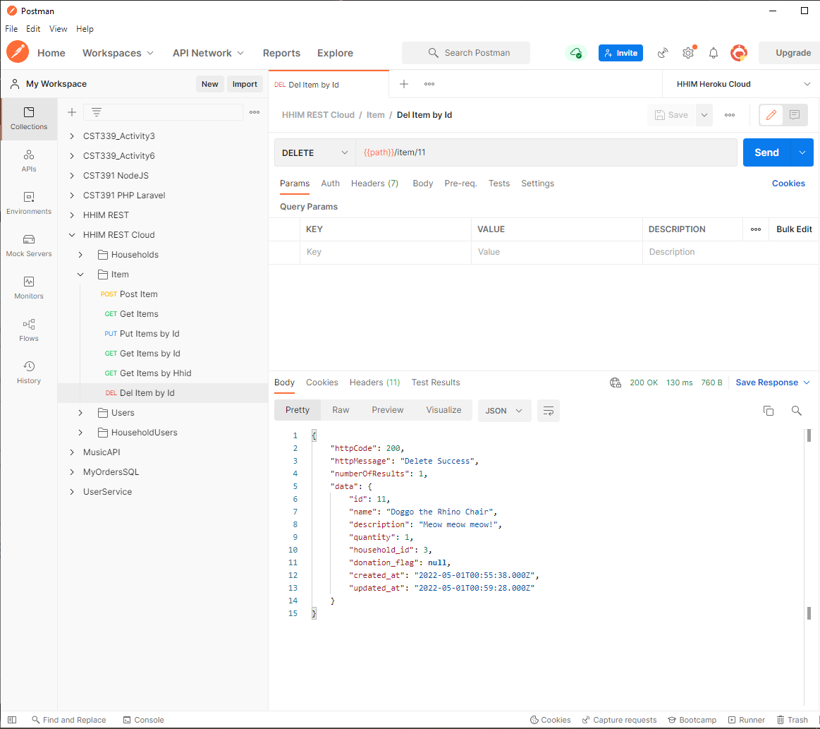

### Reports:

GET: Items for Donation Summary

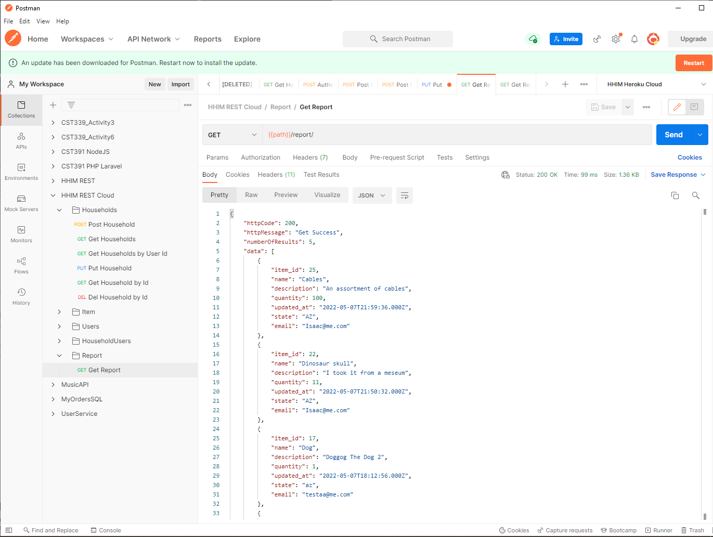

GET: Households Summary

<Not Yet Implemented>

## Front-End Tests:

1 Register FE - Register Component. Test001

BE - UserDAO

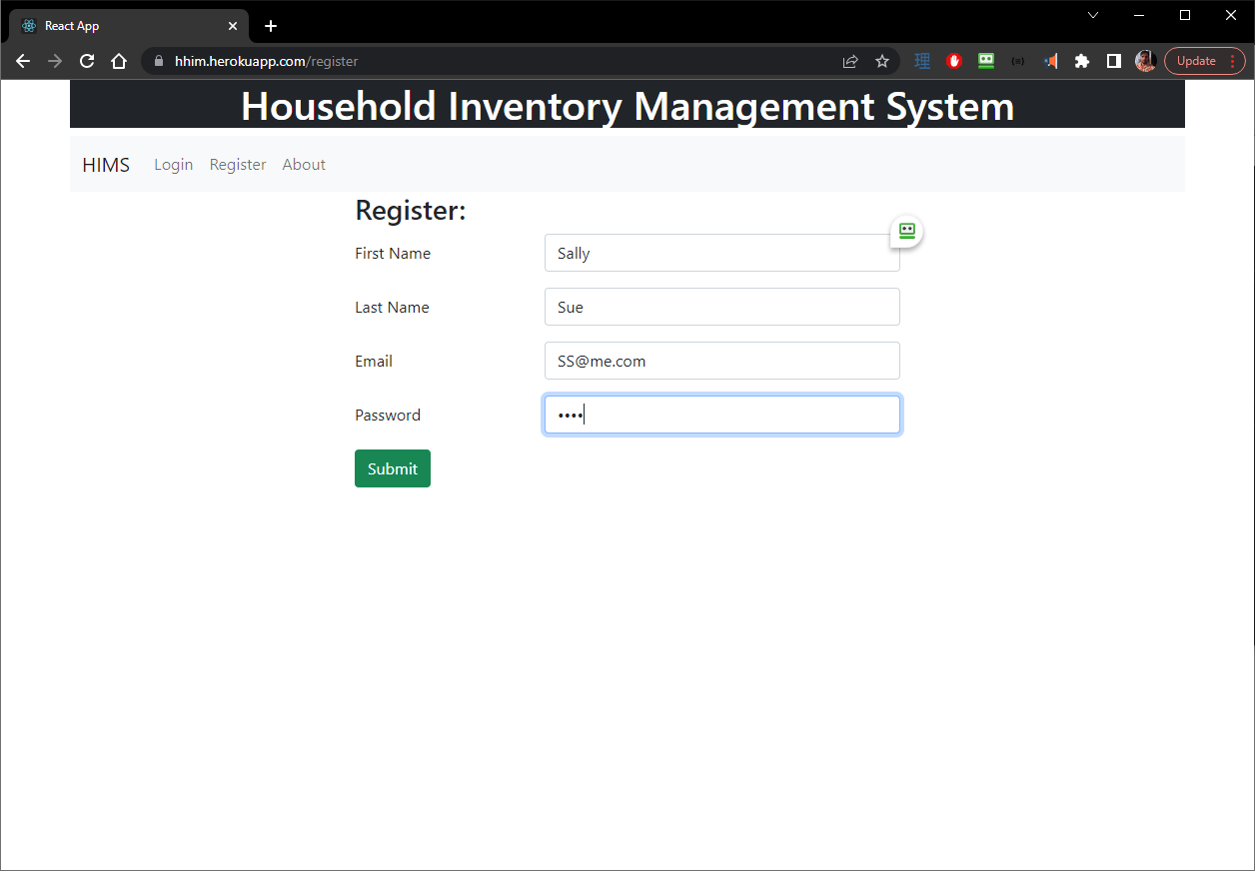

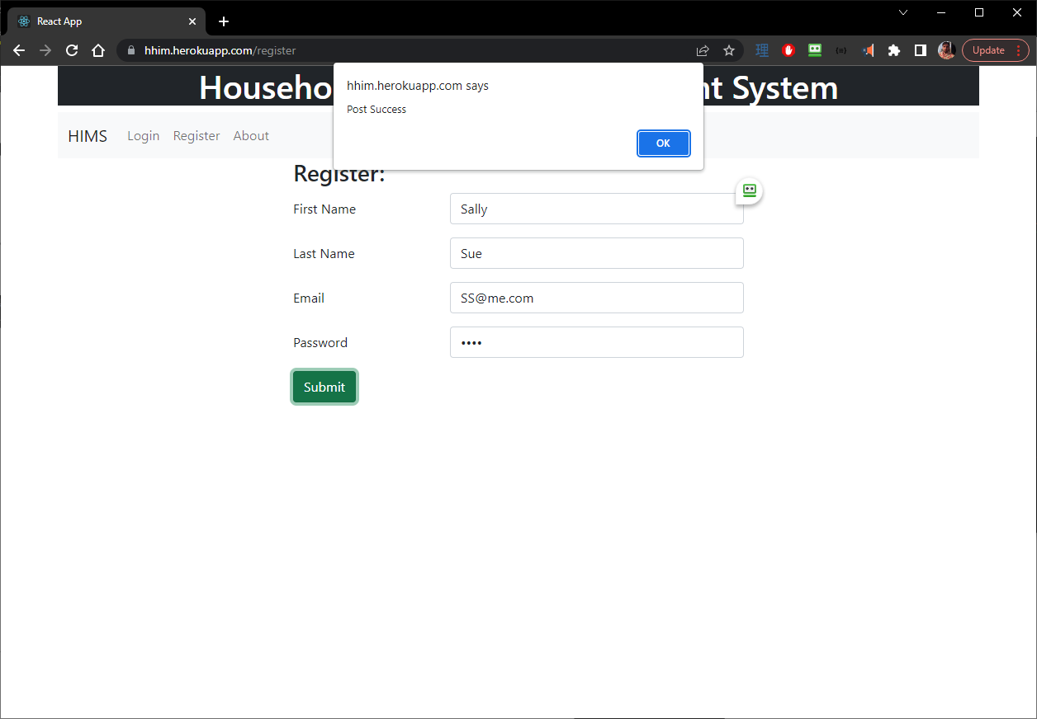

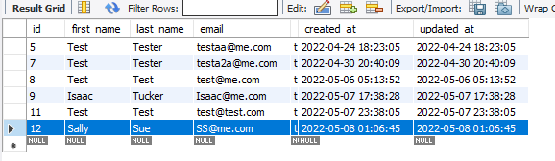

2 Login FE - Login Component. Test002

BE – UserDAO

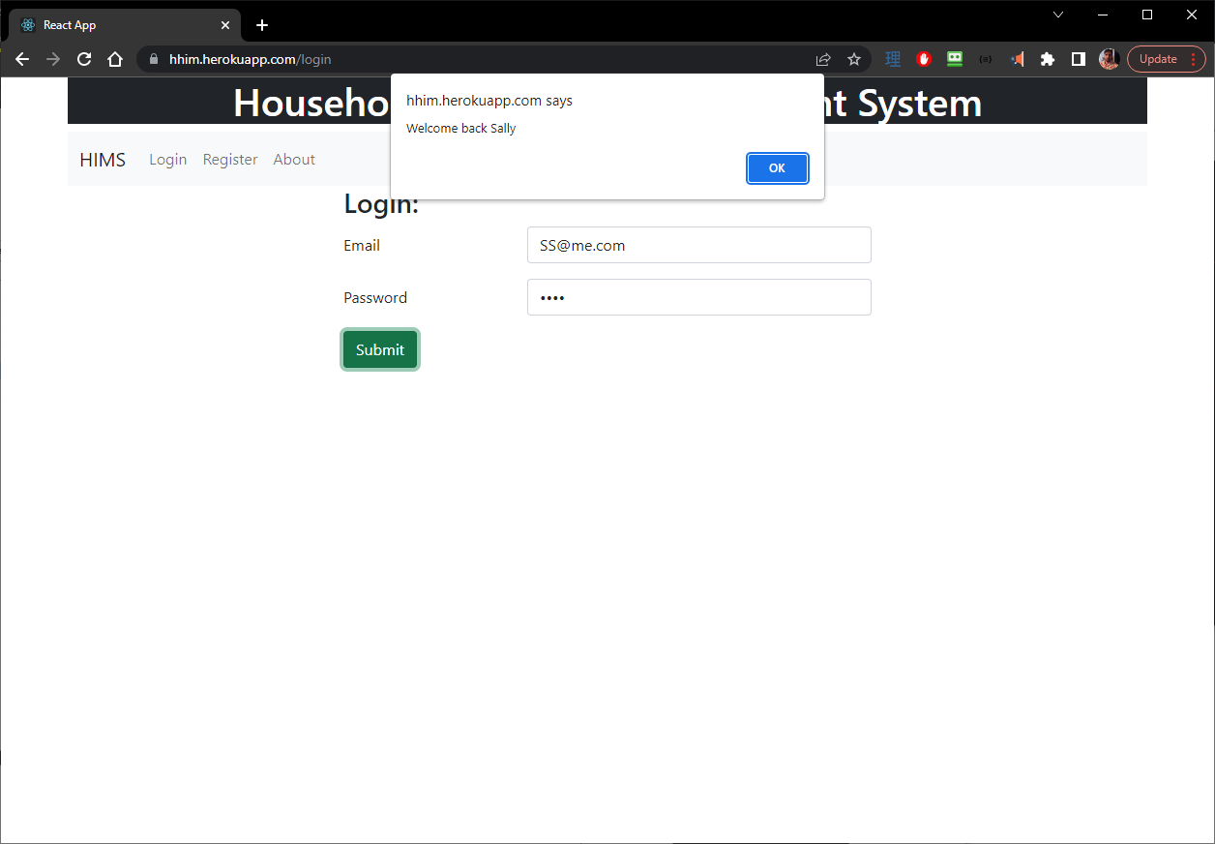

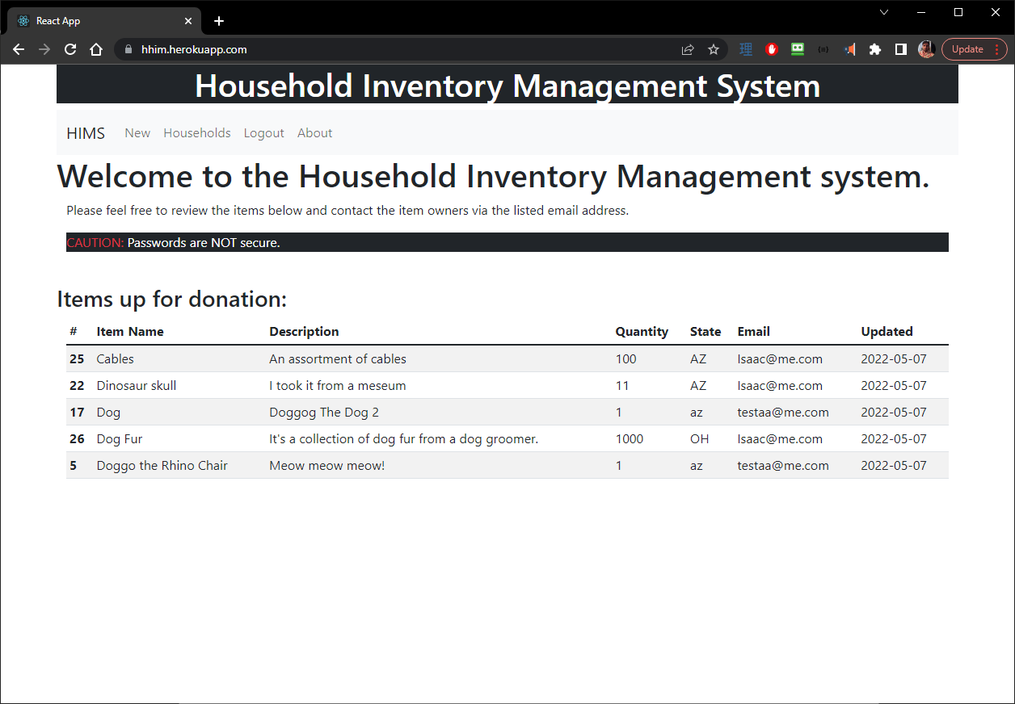

3 Add Household FE - New Household Component Test003

BE - HouseholdDAO

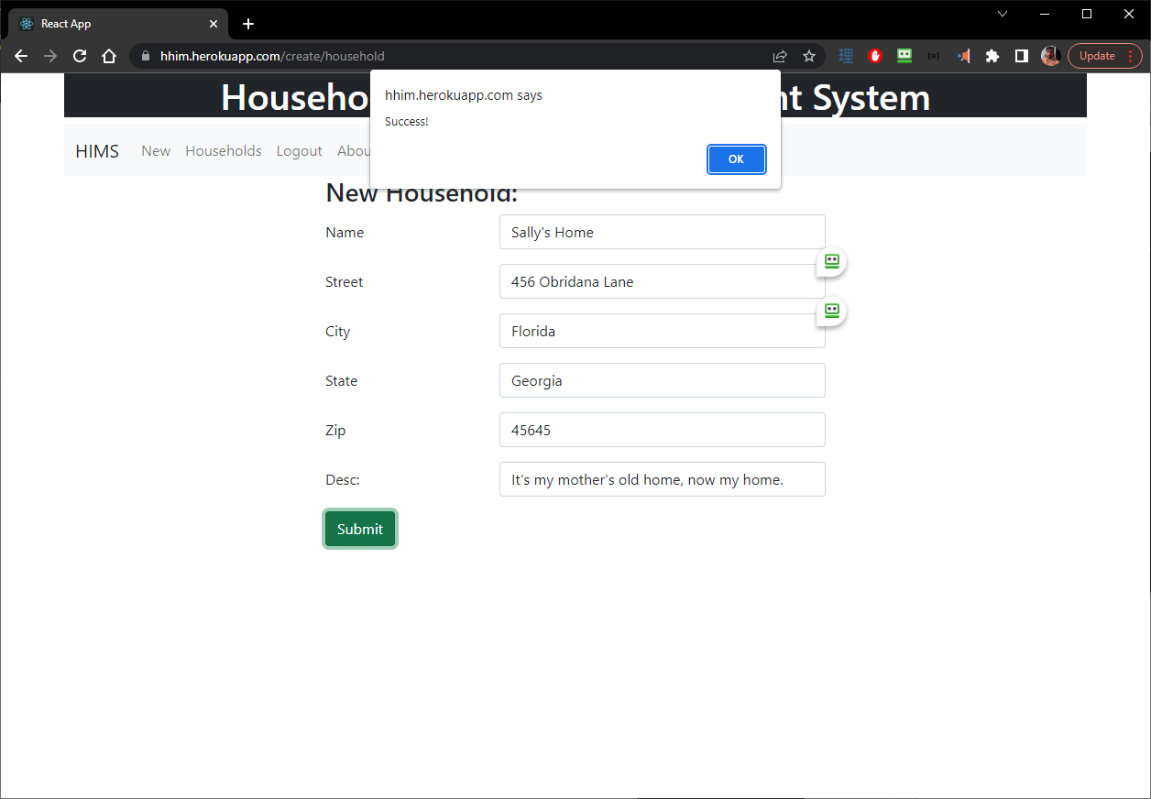



HouseholdUsers Table as well:



4 Delete Household FE - View Household Component Test004

BE - HouseholdDAO

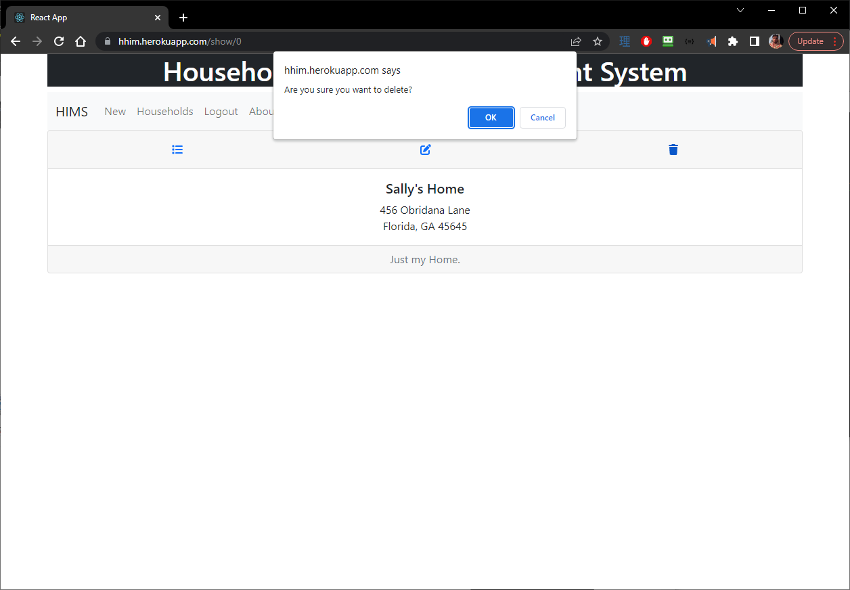

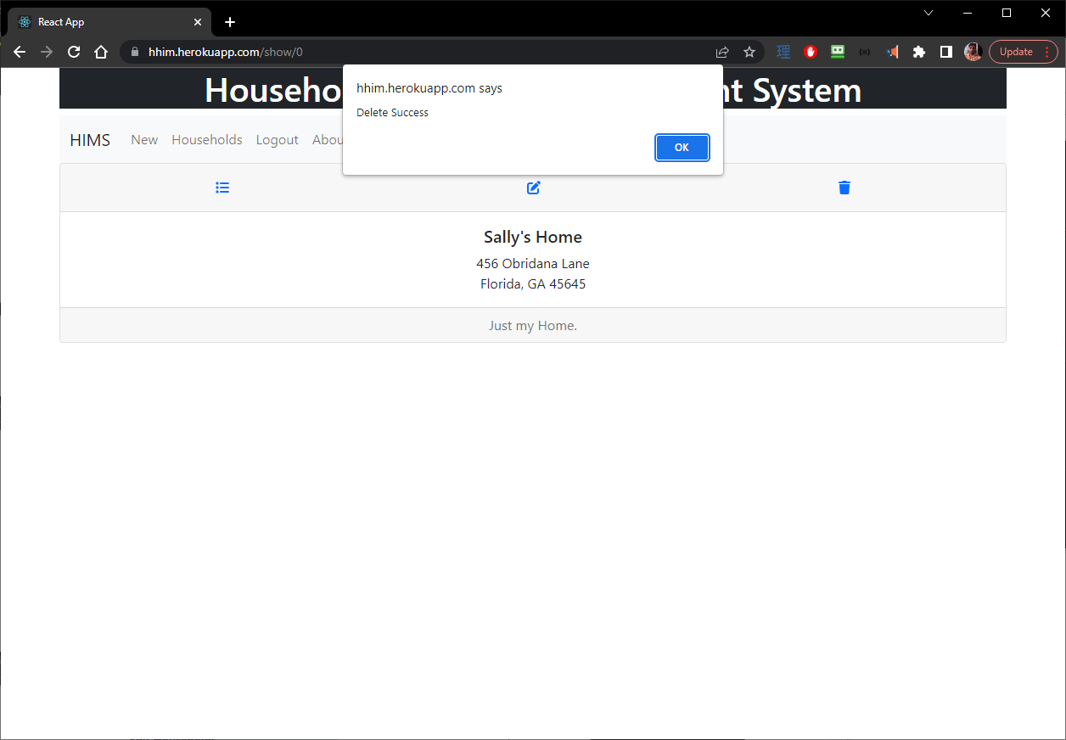

5 Update Household FE - Edit Household Component. Test005

BE - HouseholdDAO

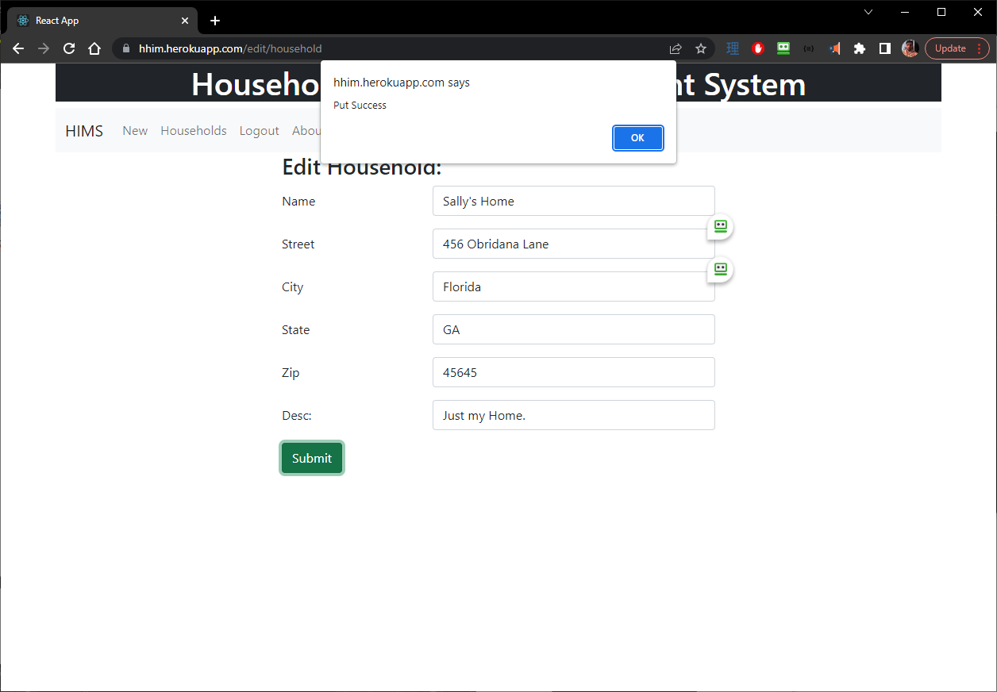



6 View Household FE - View Household Component Test006

BE - HouseholdDAO

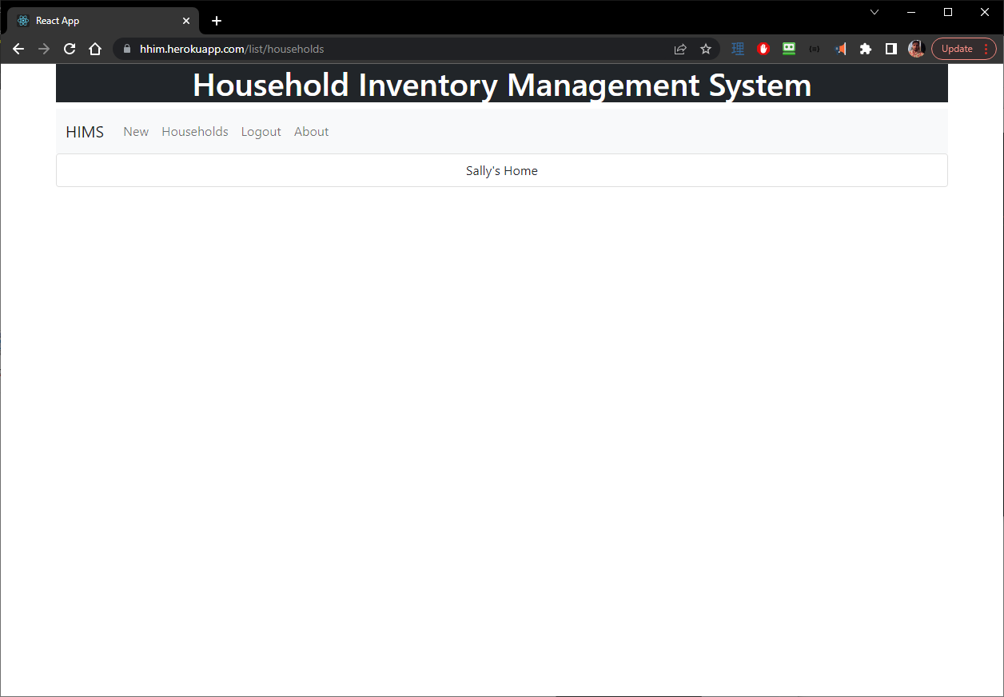

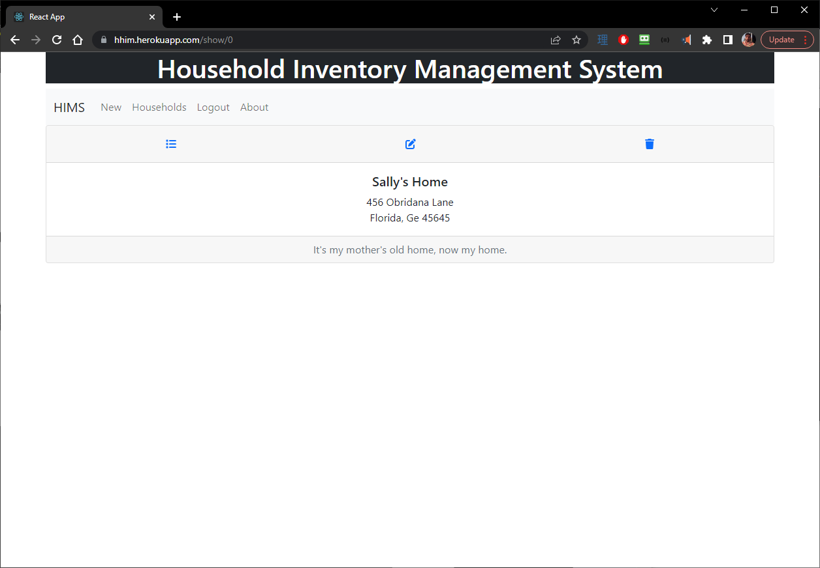

7 View Items FE - View Item Component Test007

BE – ItemDAO

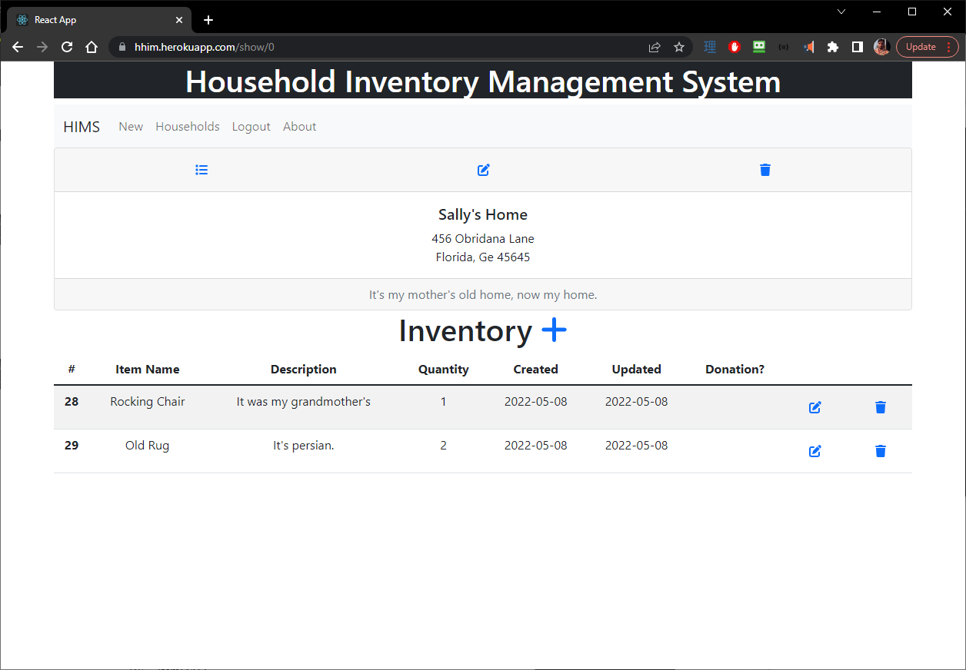

8 Add Item FE - New Item Component Test008

BE – ItemDAO

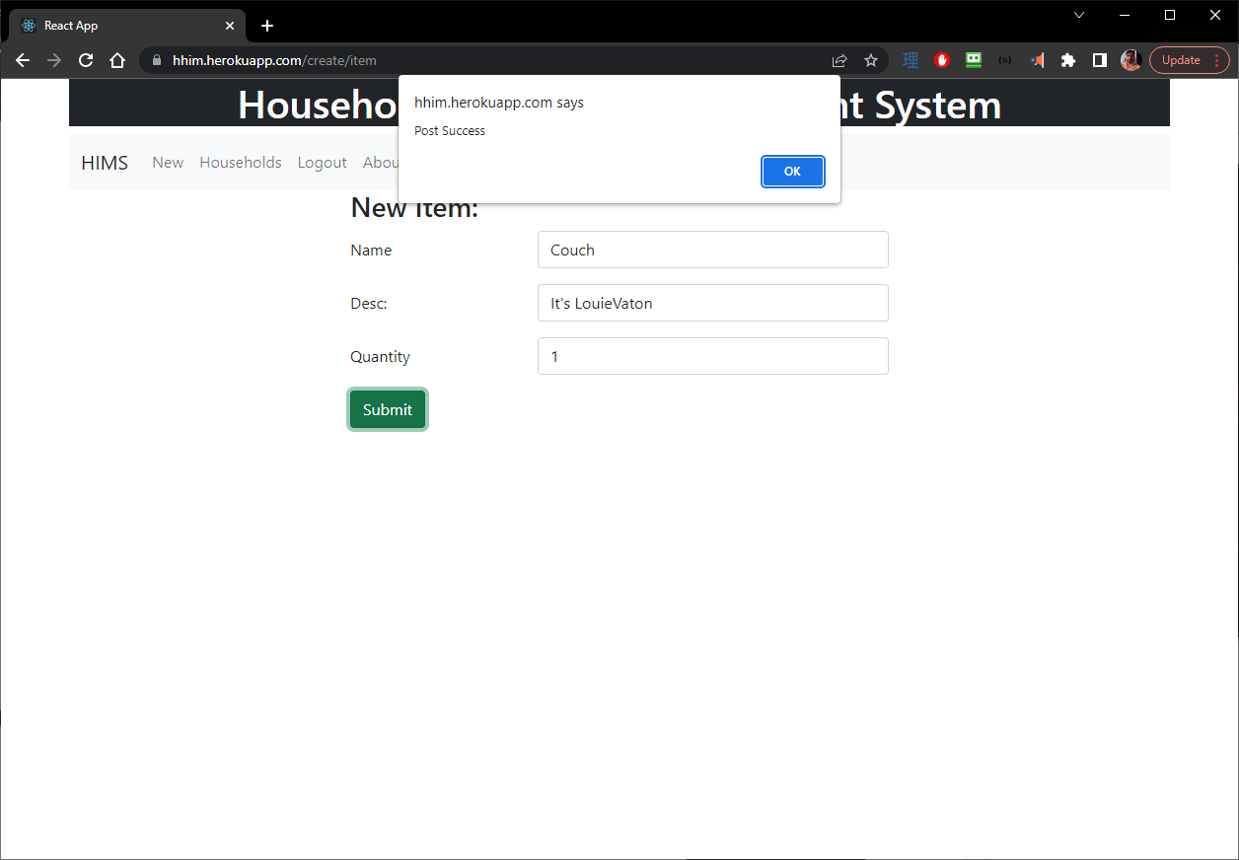

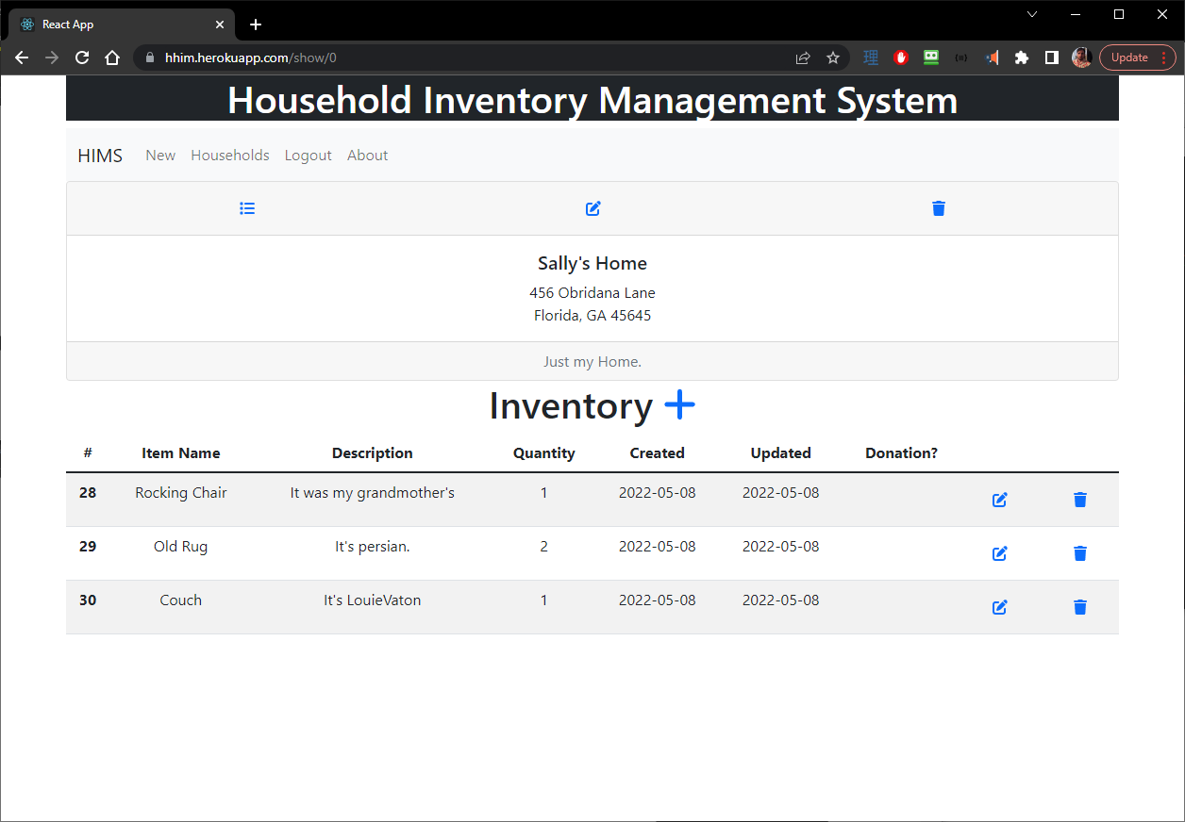



9 Update Item FE - Edit Item Component Test009

BE - ItemDAO

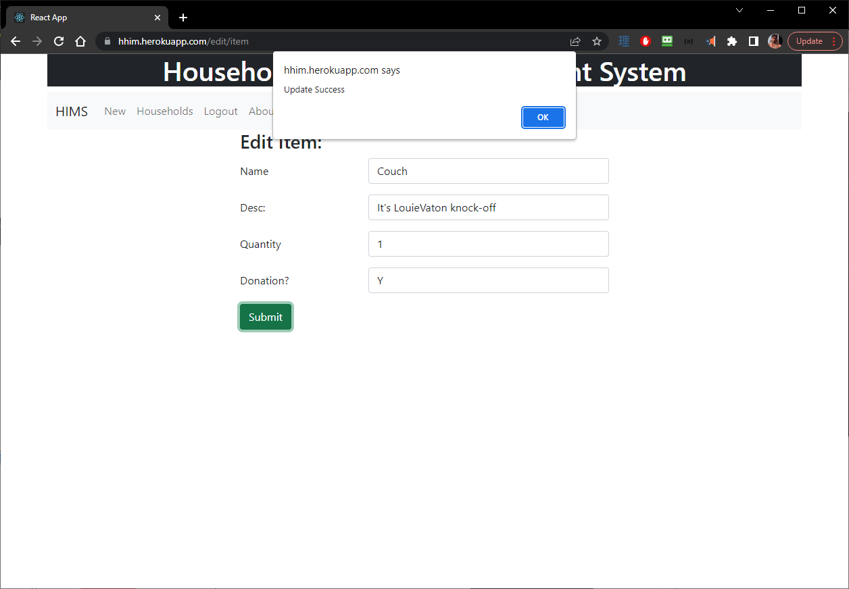

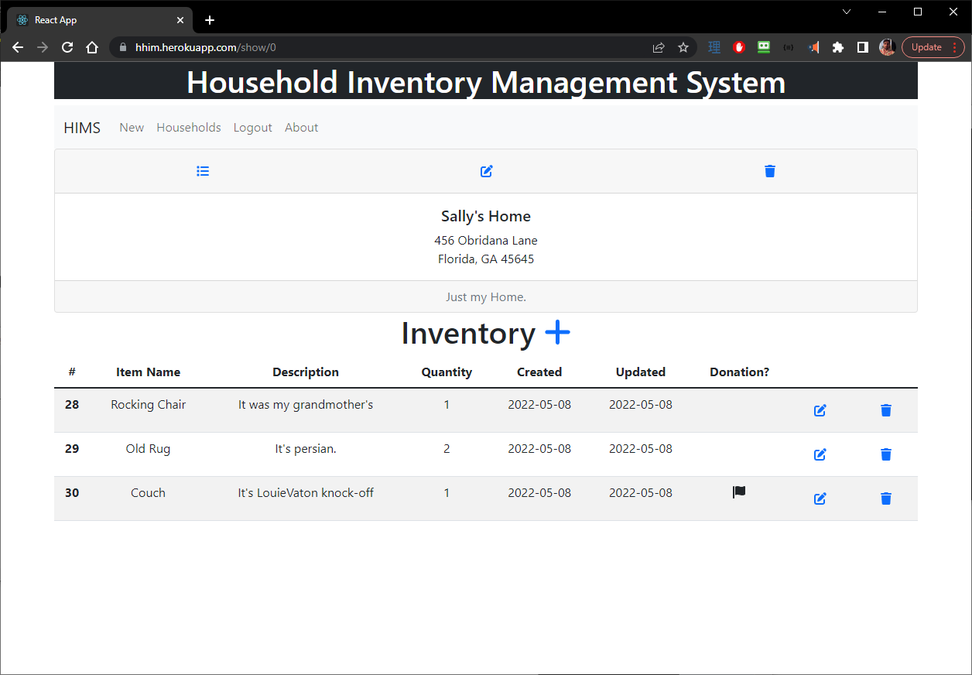

10 Delete Item FE - View Item Component Test010

BE – ItemDAO

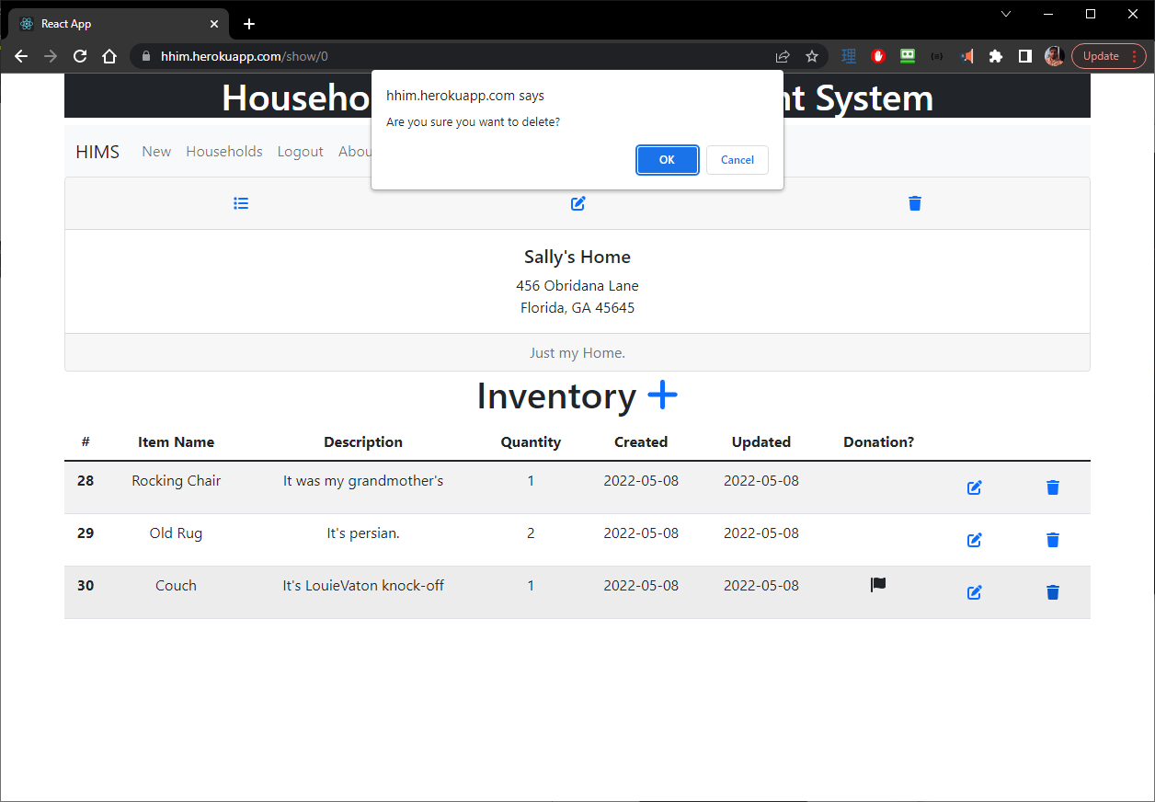

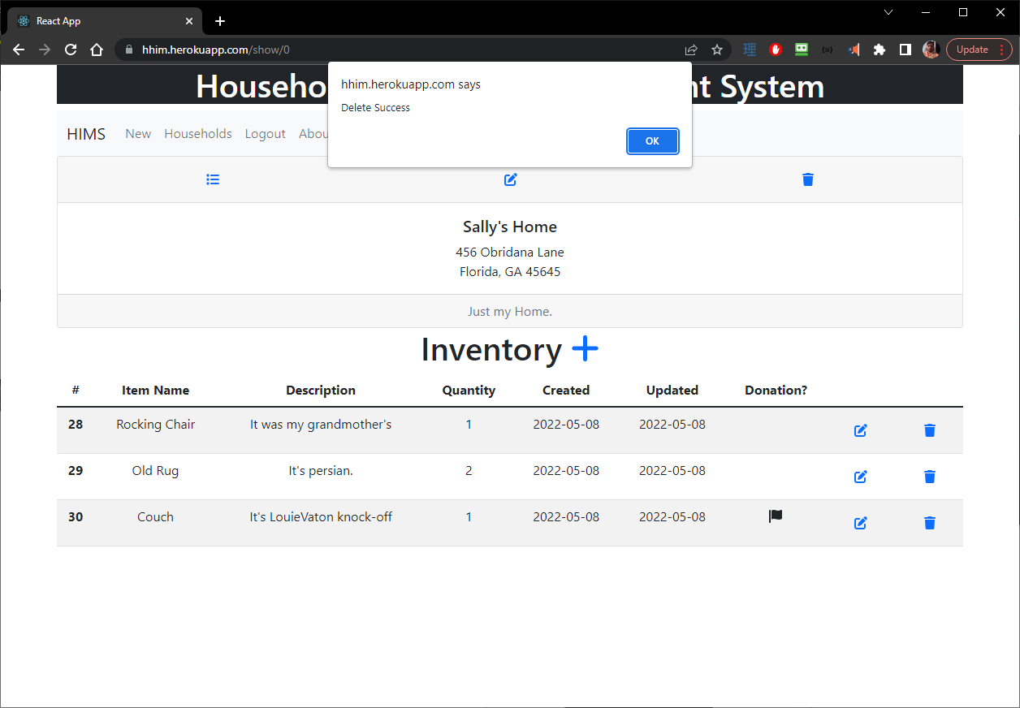

11 Flag Item for DonationFE - View Item Component Test011

BE – ItemDAO





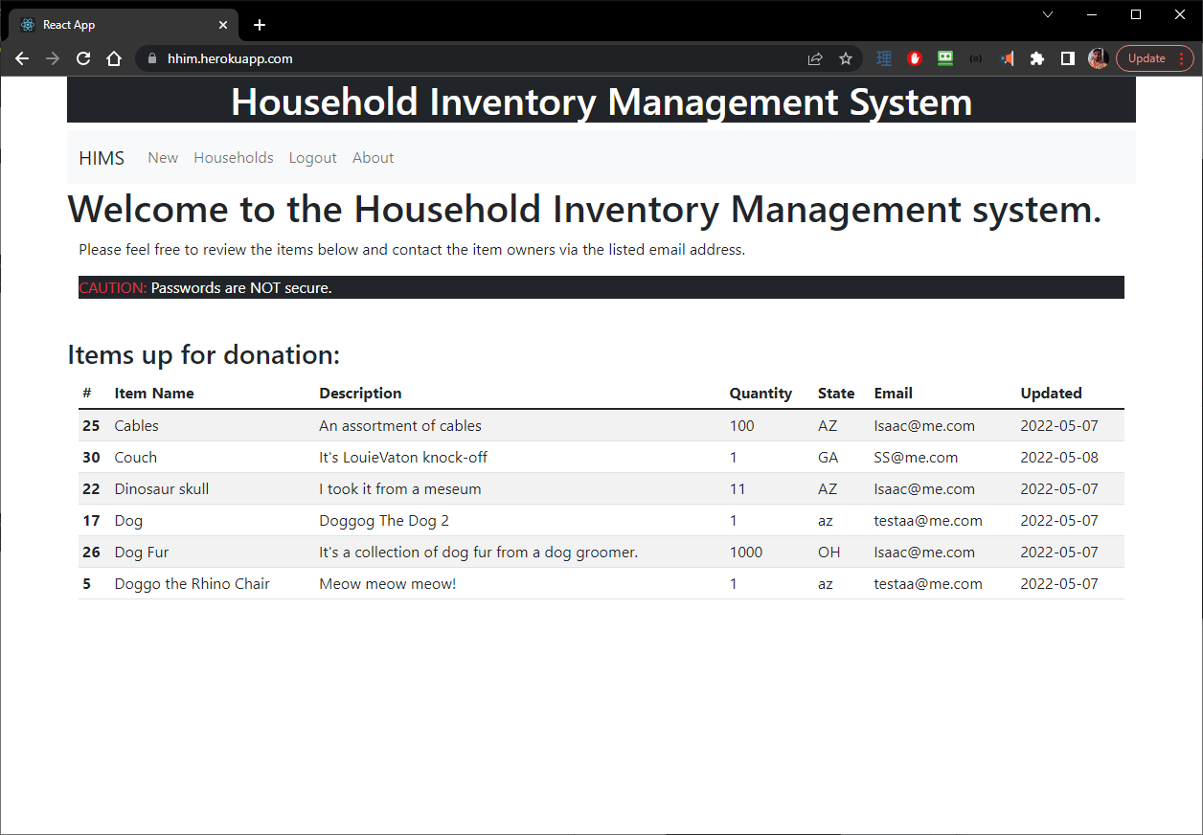

12 Invite Collaborators FE - View Household Component Test012

BE - HouseholdUsersDAO

<NOT YET IMPLEMENTED>

# Application Demonstration

Demo: Sprint 1: <https://www.loom.com/share/8215f45638ec40cda28c0e2cef7a3705>

Demo: Sprint 2: <https://www.loom.com/share/872761b86ac64b6a88128ae8d694be36>

Demo: Sprint 3: <https://www.loom.com/share/5932d696790a4d10a8b91fd2d9869f6d>

Demo: Sprint 4: